**AUTOMATION SYSTEM FOR VEHICLE DAMAGE DETECTION AND COST ESTIMATE BY USING COMPUTER VISION.**

**Smart Claim AI**

PSPD by

E. A. D. Rasheli Nimansha Jayalath

(2019277 / W1761263)

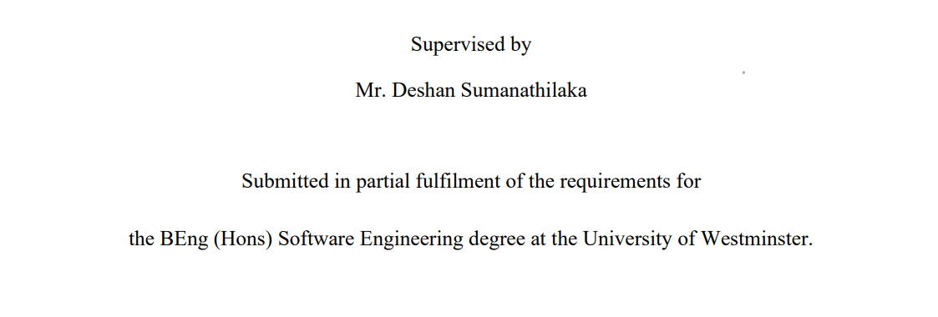

16th of February

# ABSTRACT

The vehicle collision industry faces numerous challenges, including rising costs and increasing complexity of repairs. Insurance companies are tasked with managing the claims process, which involves evaluating the damage and estimating the cost of repairs. This process can be time-consuming and prone to errors, resulting in increased costs and delays. In recent years, insurance companies have started using advanced technologies such as artificial intelligence (AI) and machine learning to streamline the claims process and reduce costs.

The proposed system offers a novel approach to the problem of vehicle damage detection, providing a more accurate and efficient solution that eliminates the possibility of human error and improves the customer experience. By utilizing computer vision and deep learning algorithms, the proposed system aims to eliminate human error and provide a consistent and reliable solution for damage detection. This approach not only reduces the time taken for assessment but also ensures greater accuracy, reducing the possibility of disputes and dissatisfaction among customers.

This study examined various requirements elicitation methodologies including surveys, literature reviews, interviews, observations, and brainstorming. Through this research, valuable findings were obtained that provided essential information and requirements for the proposed system.

The system will be designed to be accessible via a web application, which will enable drivers to send photographs of the damaged vehicle and get them to the system for automatic assessment. By automating the damage estimation process, it is hoped to reduce the time and energy required from both the customer and the insurance company. The use of an automated system will help reduce the time and resources consumed in the insurance claim process, and also ensure the safety of passengers and other parties involved in future accidents.

This research proposes the development of an automated system utilizing a fine-tuned Yolov5 model trained on a large dataset to enhance the accuracy and efficiency of vehicle collision damage detection and cost estimation, ultimately offering a more practical and streamlined solution for clients to submit photos and receive results, and reducing the time and resources required for the insurance claims process. The proposed system will use Vehicle damage classification, Image processing and Mask R-CNN model, Yolov5 model architecture to identify damages from images and provide a fast and accurate estimate of the cost of repairs.

**Keywords**: Image Processing, Vehicle Damage Classification, Deep Learning.

**CONTENTS**

ABSTRACT ii

1 Chapter 01: INTRODUCTION 1

1.1 Chapter Overview 1

1.2 Problem Domain 1

1.2.1 Vehicle Collision Industry Challenges and Insurance Claims and Processes 2

1.2.2 Damage Detection and Cost Estimation Evaluation 2

1.2.3 Computer Vision and Machine Learning Techniques 2

1.2.4 Streamlined and Hassle-Free Claims Process 2

1.2.5 Automated Systems for Accident Assessment 3

1.3 Problem Definition 3

1.3.1 Problem Statement 4

1.4 Aims and Objectives 4

1.4.1 Aims 4

1.4.2 Research Objectives 5

1.5 Novelty of the Research 7

1.5.1 Problem Novelty 7

1.5.2 Solution Novelty 7

1.6 Research Gap 8

1.7 Contribution to the Body of Knowledge 9

1.7.1 Contribution to the Problem Domain 9

1.7.2 Contribution to the Research Domain 10

1.8 Research Challenge 11

1.9 Chapter Summary 11

2 Chapter 02: SRS 12

2.1 Chapter Overview 12

2.2 Rich Picture Diagram 12

2.3 Stake Holder Analysis 13

2.3.1 Stakeholder onion model 13

2.3.2 Stakeholder Viewpoints 13

2.4 Selection of Requirement Elicitation Methodologies 15

2.5 Discussion of Findings 17

2.5.1 Findings from Literature Review 17

2.5.2 Findings from Survey / Questionnaire 19

2.5.3 Findings from Formal Interviews with The Insurance Agent 22

2.5.4 Findings from Observation 24

2.5.5 Findings from Brainstorming 25

2.5.6 Summary of Findings 25

2.6 Context diagram 26

2.7 Use case Diagram 26

2.8 Use case descriptions. 26

2.9 Requirements 27

2.9.1 Functional Requirements 28

2.9.2 Non-Functional Requirements 28

2.10 Chapter Summary 29

3 Chapter 03: DESIGN 30

3.1 Chapter overview 30

3.2 Design Goals 30

3.3 High level Design 31

3.3.1 Architecture Diagram 31

3.3.2 Discussion of tiers of the Architecture 32

3.4 Low-level Design 33

3.4.1 Choice of design paradigm 33

3.4.2 Data flow diagram level 1 34

3.5 Design Diagrams 34

3.5.1 Component Diagram 34

3.5.2 System Process Flow Chart 36

3.5.3 User Interface Design 36

3.6 Chapter summary 37

4 Chapter 04: INITIAL IMPLEMENTATION 38

4.1 Chapter Overview 38

4.2 Technology Selection 38

4.2.1 Technology Stack 38

4.2.2 Algorithmic Analysis 39

4.2.3 Data-set Selection 40

4.2.4 Development Frameworks 40

4.2.5 Programming Languages 40

4.2.6 Libraries 40

4.2.7 IDE 41

4.2.8 Summary of Technology Selection 41

4.3 Implementation of the Core Functionality 41

4.3.1 Source code Ipynb file 41

4.3.2 Prototype web application 43

4.4 Chapter Summary 43

5 Chapter 05: CONCLUSION 44

5.1 Chapter Overview 44

5.2 Deviations 44

5.2.1 Scope related deviations. 44

5.3 Initial Test Results 45

5.4 Demo of the Prototype 45

5.5 Chapter Summary 45

REFERENCES I

APPENDIX III

Appendix A – From Use case Description III

Appendix B – From Implementation V

Flask application Implementation source code V

Appendix C – From survey VI

1. Survey question 4 - Chart of responses VII

2. Survey question 5 - Chart of responses VII

3. Survey question 6 - Chart of responses VII

4. Survey question 7 - Chart of responses VIII

5. Survey question 8 - Chart of responses VIII

6. Survey question 9 - Responses VIII

7. Survey question 10 - Chart of responses IX

8. Survey question 11 - Chart of responses IX

Appendix D – Diagrams X

Sequence Diagram X

List of Figures

Figure 1 - Rich Picture Diagram 12

Figure 2 - Stakeholder onion model 13

Figure 3 - Context Diagram 26

Figure 4 - Use case diagram 26

Figure 5 - Architecture Diagram 32

Figure 6 - Data flow diagram level 1 34

Figure 7 - Component Diagram 35

Figure 8 - System flow chart 36

Figure 9 - User Interface Design 37

Figure 10 - Prototype web application 43

Figure 11 - Initial Test Results 45

List of Tables

Table 1 - Research Objectives 6

Table 2 - Stakeholder Viewpoints 15

Table 3 - Findings from Literature Review 19

Table 4 - Findings from Survey / Questionnaire 22

Table 5 - Findings from Formal Interviews with The Insurance Agent 24

Table 6 - Use case description 27

Table 7 – Requirements description 27

Table 8 - Functional Requirements 28

Table 9 - Non-Functional Requirements 29

Table 10 - Design Goals 31

Table 11 - Technology Stack 38

Table 12 - Summary of Technology Selection 41

Abbreviations

|  |  |
| --- | --- |
| **Abbreviation** | **Definition** |
| AI | Artificial intelligence |
| APP | application |
| CNN | Convolutional Neural Network |
| CSS | Cascading Style Sheets |
| OpenCV | Open Source Computer Vision Library |
| FR | functional requirements |
| GDPR | General Data Protection Regulation |
| HTML | HyperText Markup Language |
| ID | identification |
| IDE | An integrated development environment |
| IT | Information technology |
| JS | Javascript |
| ML | Machine Learning |
| SQL | Structured Query Language. |
| NFR | non-functional requirements |
| OOA | object-oriented analysis |
| RCNN | Region-based Convolutional Neural Network |
| RO | Research Objectives |
| SRS | Software Requirements Specifications |
| SSADM | Structured Systems Analysis and Design Method |
| SVM | Support vector machine |
| UI | user interface |
| VGG | Visual Geometry Group |
| YOLOv5 | You Only Look Once version 5 |

# Chapter 01: INTRODUCTION

## Chapter Overview

This introductory chapter presents an overview of the research project, outlining its scope and purpose. The report aims to highlight the significance and magnitude of a pressing problem faced by the vehicle collision industry - the increasing number of accidents each year and the limitations of the current damage assessment process. The chapter discusses the potential for human error and subjectivity in the existing system, which can lead to fraudulent claims and waste of valuable resources. To overcome these challenges, the research project seeks to develop an efficient and objective system for damage detection and cost estimation evaluation. By examining the problem domain and the benefits of implementing a proper system, the chapter underscores the importance of conducting research in this area. The objectives and expected contributions of the study are also discussed to emphasize the need for a solution that can minimize waste, save time and resources, and benefit the vehicle collision industry as a whole.

## Problem Domain

Due to excessive use of private vehicles, lack of mental concentration, and busyness of people, road accidents have increased to some extent. The insurance claim process after an accident consumes considerable time and resources. The vehicle collision industry is facing many challenges because of the increasing number of accidents per year. The insurance claims process can be time-consuming and stressful for both the clients and the insurance companies, who must send agents to the accident location to estimate the damage. The assessment process involves taking photographs of the damaged vehicle and filling out forms, which can be a wasteful in terms of time and money. The current process is also prone to human error and subjective decisions by human damage assessors, as well as the risk of fraud.

This waste can be minimized by using proper technology. It will be more effective if the task of the agent who attends an accident and observes it and records the information can be done by an automated system. The damage can be identified by sending the vehicle photos taken by the vehicle owner to the system along with the insurance company. Structural damage to a vehicle can cause significant issues if not properly repaired, reducing the vehicle's strength, and causing harm to both passengers and other parties involved in a future accident (Nguyen, 2019) . To address the challenges faced by the vehicle collision industry, it is crucial to implement a proper and efficient system for damage detection and cost estimation evaluation. This system will not only help overcome the difficulties posed by the increasing number of accidents each year but also ensure that the damage assessment process is accurate and reliable. With the right technology in place, the time and resources consumed in the insurance claim process can be reduced, and the risk of human error and fraud can be minimized. By having an effective system for damage detection and cost estimation, both clients and insurance companies will benefit from a more streamlined and hassle-free process.

Vehicle collisions are a significant concern for the automotive industry due to the high number of fatalities and the associated financial losses. In addition, the process of handling insurance claims can be challenging for both the insurance company and the claimant. Therefore, it is crucial to develop an efficient and effective system to streamline the entire process, from damage detection to claim assessment.

### Vehicle Collision Industry Challenges and Insurance Claims and Processes

The vehicle collision industry faces numerous challenges, including rising costs and increasing complexity of repairs. Insurance companies are tasked with managing the claims process, which involves evaluating the damage and estimating the cost of repairs. This process can be time-consuming and prone to errors, resulting in increased costs and delays. In recent years, insurance companies have started using advanced technologies such as artificial intelligence (AI) and machine learning to streamline the claims process and reduce costs (Smith, 2020).

### Damage Detection and Cost Estimation Evaluation

Damage detection and cost estimation are critical components of the claims process. Traditionally, this process involved visual inspection of the damage by an expert. However, with the advancements in computer vision and machine learning, there has been a shift towards using technology for this purpose. Image processing and analysis tools can detect even minor damages that may be overlooked by the human eye. Furthermore, these tools can also estimate the cost of repairs accurately, leading to reduced costs and increased efficiency in the claims process (Li et al., 2020).

### Computer Vision and Machine Learning Techniques

Computer vision and machine learning techniques are being increasingly used in the vehicle collision industry for a variety of applications. These techniques can be used for damage detection, cost estimation, and even for predicting the likelihood of accidents. Convolutional neural networks (CNNs) are a popular method used for image analysis and object detection. These techniques have shown promising results in accurately detecting and classifying vehicle damages and estimating repair costs (Li et al., 2020).

### Streamlined and Hassle-Free Claims Process

A streamlined and hassle-free claims process is essential to provide a positive customer experience. In recent years, insurance companies have started using automated systems that use computer vision and machine learning to reduce the time and effort required for claims processing. These systems can quickly identify damages, estimate repair costs, and even generate repair orders. Furthermore, these systems can also provide a seamless experience for customers, allowing them to track the progress of their claims and receive updates in real-time (Smith, 2020).

### Automated Systems for Accident Assessment

Automated systems for accident assessment are becoming increasingly popular in the vehicle collision industry. These systems can use sensors, cameras, and machine learning algorithms to quickly assess the damage and provide an accurate estimate of the repair costs. These systems can be installed in vehicles and can even provide real-time updates to the driver and insurance companies. This can help reduce the time and effort required for claims processing and provide a more efficient and hassle-free experience for customers (Huang et al., 2020).

The proposed system will overcome these challenges by automating the damage estimation process using computer vision and machine learning techniques. Due to the mixed nature of scratches, it can be difficult to identify the damage from images. The project addresses a critical damage estimation method. Vehicle damage detection by using Vehicle damage classification, Image processing and Mask R-CNN model architecture. Adding multiple photographs at once as getting input and output (result) via messaging app instead of using a Web application. The driver will take photographs of the damaged vehicle using a mobile phone application, which will be automatically assessed for damage, providing a fast and accurate estimate of the cost of repairs. This will not only save time and money for both the insurance companies and their clients, but also ensure the safety of both passengers and other parties involved in a future accident.

## Problem Definition

The problem addressed in this research project is the inefficient and time-consuming nature of the vehicle insurance claims process after a collision. According to the Ministry of Transport & Civil Aviation in Sri Lanka, there are around 8000 vehicle collisions per year in the country (Ministry of transport, 2021). The current process of claiming insurance for a damaged vehicle involves informing the insurance company, taking the damaged vehicle to a repair center, and going through the repairing process, which is time-consuming and energy-intensive for both the customer and the insurance company (Araujo, 2022). Additionally, claims leakage causes insurance companies to waste a lot of money (Ernst & Young LLP, 2015).

The process of claiming insurance after a vehicle collision can be a complex and stressful experience for the vehicle owner. After informing the insurance company of the collision, an insurance agent will come to the accident location to estimate the damage. The agent must confirm that damage has occurred and provide a damage row estimation for the vehicle. The damaged vehicle is then taken to a repair center where the repair shop also gives a damage estimation, and the insurance company must confirm that both estimations are similar to start with the repairing process (Araujo, 2022). This whole process can be time-consuming, and when a traffic collision happens, many people on the road are affected.

The difference between the ideal and actual settlement of a claim is known as claim leakage. Visual inspection and approval are being utilized to decrease claims leakage. But doing inspection might take a long time and result in delays of claims processing.

To address this problem, the objective of this research project is to automate the damage estimation process and improve the efficiency of the vehicle insurance claims process. By automating the damage estimation process, it is hoped to reduce the time and energy required from both the customer and the insurance company. An automated system for doing review and approval will be of efficient assistance in speeding up the process. Uploading photos to a web app or mobile app to see the results in case of an accident is not practical. An automated system where you can contact a phone number previously provided by the insurance company and send images and receive results is more appropriate. The proposed solution to this problem is to use computer vision and machine learning techniques to automatically detect vehicle damage after an accident using photographs taken at the accident scene.

### Problem Statement

This research proposes the development of an automated system utilizing a fine-tuned Yolov5 model trained on a large dataset to enhance the accuracy and efficiency of vehicle collision damage detection and cost estimation, ultimately offering a more practical and streamlined solution for clients to submit photos and receive results, and reducing the time and resources required for the insurance claims process.

## Aims and Objectives

### Aims

The aim of this research project is to design and develop an efficient and automated system for damage detection by training a model and cost estimation in the vehicle collision industry using computer vision and machine learning techniques. The proposed system will use Vehicle damage classification, Image processing and Mask R-CNN model, Yolov5 model architecture to identify damages from images and provide a fast and accurate estimate of the cost of repairs. The system will be designed to be accessible via a mobile phone application, which will enable drivers to take photographs of the damaged vehicle and send them to the system for automatic assessment. The use of an automated system will help reduce the time and resources consumed in the insurance claim process, and also ensure the safety of passengers and other parties involved in future accidents. The project aims to address the challenges faced by the vehicle collision industry, including rising costs and increasing complexity of repairs, by providing a streamlined and hassle-free claims process. The proposed system will provide a more efficient and effective way to manage insurance claims, helping both clients and insurance companies to benefit from reduced costs, increased efficiency, and a more seamless claims process. Ultimately, the goal of the research project is to contribute to the development of a more reliable, accurate, and automated system for damage detection and cost estimation in the vehicle collision industry.

### Research Objectives

|  |  |  |
| --- | --- | --- |
| **Objective** | **Description** | **Learning Outcome** |
| Literature Review | In-depth analysis of the following areas related to the development of a system for the vehicle insurance industry:   * **RO1**: **Recognizing the Need for a System in the Vehicle Insurance Industry**   Explore the current state of the vehicle insurance industry and identify the challenges and issues faced by insurers in providing effective services to their customers. This will involve examining existing literature, reports, and studies on the vehicle insurance industry, including consumer behavior, market trends, and regulatory developments. The review will also assess the role of technology in the industry and highlight the potential benefits of developing a system that can improve the insurance experience for customers and insurers alike.   * **RO2**: **Identifying Proper Dataset Creation Methodology**   Investigate the different methodologies for creating datasets that can be used to train machine learning algorithms for the vehicle insurance industry. This will involve a comprehensive analysis of the existing literature on data collection, data processing, and data cleaning techniques. The review will also explore the different sources of data that can be used, including social media, telematics, and other IoT devices, and identify the best practices for ensuring data accuracy, reliability, and consistency.   * **RO3**: **Identifying Suitable Machine Learning Algorithms to Achieve Good Accuracy**   Identify the most appropriate machine learning algorithms for achieving high accuracy in the vehicle insurance industry. This will involve a critical assessment of the strengths and limitations of various algorithms, including supervised and unsupervised learning, decision trees, neural networks, and deep learning. The review will also examine the different factors that can affect the performance of machine learning models, such as feature selection, model optimization, and hyperparameter tuning, and suggest best practices for achieving optimal results. | L01, L06 |
| Requirement Elicitation | Requirement elicitation is a crucial phase in the software development life cycle that aims to identify and gather real user needs to create a system that satisfies the end-users. Here are some elaborated objectives for in-depth gathering of user needs:  **Identify real user needs for the community:** Identify the actual user requirements by conducting a comprehensive analysis of the community's needs. This includes identifying the users' problems, concerns, and pain points, and understanding their expectations and goals for the system.  **Analyze the collected requirements:** Once the user needs are identified, the next objective is to analyze the collected requirements to ensure that they are valid, complete, and consistent. This involves conducting various techniques such as requirement validation, prioritization, and negotiation to refine and clarify the user requirements.  **Identify system functionality**: Identify the system's functionality that will satisfy the user requirements. This includes defining the system's features, functionalities, and interfaces that are necessary to meet the users' needs. The system functionality should be derived from the user requirements, and it should be well-defined, measurable, and achievable. | L02, L03, L04, L05, L06 |
| Design | Development of the system.   * Create a simple web application and automated system with the image recognition model and the implementation process. * Design the back-end and front-end (User interface) architecture of the web application and the automated system which will be used through a messaging app. * Create user-friendly application interfaces. | L03, L04, L06, |
| Implementation | Creating a functional prototype of a car damage-detecting detecting system using the appropriate hardware and software components.   * To identify the exact damage area and the level of damage severity of a the damaged vehicle. * To evaluate severity levels and identify the most accurate severity of damage. * Increasing the accuracy of critical vehicle damage detection from images and labels define damage classification. * Implementation of a system that can assess the severity of damage to a vehicle from an image and estimate the cost of severe damage. * Generate car damage report including damage type and severity and estimated cost. | L03, L04, L06 |
| Evaluation | * Create a test plan for each unit and model to validate system requirements. | L04, L06 |

Table - Research Objectives

## Novelty of the Research

### Problem Novelty

In the field of vehicle collision damage assessment, there is a pressing need to address the issue of human error in the damage detection process. Currently, the process of detecting damage on a vehicle involves manual inspection, where a human inspector evaluates the extent of damage on a vehicle. This approach is not only time-consuming but also susceptible to human bias and inconsistencies, leading to inaccurate assessments. This leads to increased costs, disputes, and ultimately affects customer satisfaction.

To address this issue, the proposed research aims to provide a more accurate and efficient solution for detecting vehicle damage. By utilizing computer vision and deep learning algorithms, the proposed system aims to eliminate human error and provide a consistent and reliable solution for damage detection. This novel approach to damage detection not only reduces the time taken for assessment but also ensures greater accuracy, reducing the possibility of disputes and dissatisfaction among customers.

### Solution Novelty

The proposed solution to this issue is the development of an automated vehicle damage detection system that utilizes computer vision and deep learning algorithms. The system will be trained on a large dataset to accurately detect and assess the extent of damage on a vehicle. This will be achieved through the implementation of a fine-tuned Yolov5 model, which has been proven to be effective in image classification and recognition tasks. This solution represents a significant departure from the current manual approach to damage detection. By automating the process, the proposed system eliminates the possibility of human error and provides a consistent and accurate solution. Furthermore, the system will also provide an easy and practical solution for clients to submit photos and receive results, further improving the overall customer experience. In conclusion, the proposed solution offers a novel approach to the problem of vehicle damage detection, providing a more accurate and efficient solution that eliminates the possibility of human error and improves the customer experience.

## Research Gap

Vehicle body damage is a common problem for car owners and insurance companies. Damage to the vehicle body can occur due to various reasons, such as accidents, weather conditions, and vandalism. (Lin and Tsai, 2019) In recent years, many studies have been conducted to detect and classify moderate and minor damages in the vehicle body. However, there is a research gap in identifying severe damage in the vehicle body, which is a combination of moderate and minor damages and beyond. Identifying severe damage in the vehicle body is crucial for assessing the cost of repairing the vehicle and determining whether it is feasible to repair or replace the car.

One way to solve this research gap is by using image processing technology. Several studies have shown that image processing techniques can effectively identify and classify the extent of damage in the vehicle body. One advantage of using image processing technology is that it is more practical than using sensor technology, which can be costly and not suitable for large scale projects (Gontscharov et al., 2014). Moreover, image processing technology can be easily implemented using modern phones with camera capabilities, making it accessible to a wide range of users (Parasuraman et al., 2017) .

Kyu and Woraratpanya (Kyu and Woraratpanya, 2020) proposed a deep learning-based algorithm for car damage detection and classification. Their model uses pre-trained VGG models to detect the damaged part of a car and assess its location and severity. However, their proposed model still faces the overfitting problem in models. To address this issue, they suggest utilizing other types of regularization techniques and other pre-trained CNN models with a large dataset. Zhang (Zhang et al., 2020) developed a detection algorithm based on deep learning for vehicle damage detection. Their proposed transfer-learning and improved Mask RCNN-based method is more universal and can better adapt to various aspects of car damage images. However, they noted the need for data expansion to increase the size of the dataset, collect more car damage images under different weather conditions and different levels of illumination, enhance the data, improve the edge-contour enhancement of images, and make the masking of the damaged areas of the car more accurate.

Dhieb (Dhieb et al., 2019) proposed a novel framework to detect, locate, and identify damage severity on vehicles using CNN, transfer learning, and Mask R-CNN techniques. Their integrated deep learning pipeline was suggested to identify structures followed by a fine-grained damage classification. Using this method, it is possible to not only detect the damage but also identify the severity of the damage. They used an Inception-Resnet pre-trained model as a feature extractor. Harshani and Vidanage (Harshani and Vidanage, 2017) proposed an image processing-based approach for severity and cost prediction of damages in the vehicle body using a computational intelligence approach. They used the Scare Invariant feature extraction method and SVM classification to identify minor, moderate, and severe damages. However, the image dataset used was of localized damaged areas, and an image from a relatively big distance is not suitable for this approach.

Koch (Koch et al., 2018) focused on predicting the damaged parts of a low-speed vehicle crash using machine learning. They used the ‘tfresh’ algorithm for feature extraction and optimized the extracted features using ensemble learning methods due to the limited size of the train dataset. However, this method is only applicable to low-speed vehicle crashes. There are recent studies that pinpoint a vehicle's damage. But there is no research or products to identify damage in a vehicle by using photographs which are taken in an uncontrolled environment such as rain (Waqas et al., 2020).

More research is needed to detect damages and estimate their level accurately in vehicles. Existing studies are promising, but there is a gap in identifying severe damage. Future studies can use other deep learning models, regularization techniques, and feature extraction methods with a larger dataset. Additionally, the impact of weather and lighting conditions should be explored.

## Contribution to the Body of Knowledge

### Contribution to the Problem Domain

The manual tools currently used for damage detection in the vehicle collision industry are subject to human error and lack consistent accuracy. The process of manual damage detection involves an individual physically inspecting the vehicle for damage and then documenting the findings. This method is not only time-consuming but also relies heavily on the expertise and experience of the individual conducting the inspection. Moreover, the accuracy of the results can be impacted by various factors such as lighting conditions, the angle of the inspection, and the inspector's visual acuity. These limitations result in inconsistent and often inaccurate damage assessments, leading to disputes between insurance companies and policyholders.

The proposed automated system aims to address these limitations and provide a more consistent and accurate method of damage detection. By leveraging computer vision technology and fine-tuning a Yolov5 model, the system will analyze images of the vehicle and provide a detailed report on the extent of damage and an estimated cost for repairs. The use of computer vision and machine learning algorithms will minimize the dependency on human error and provide more consistent and reliable results. This system not only has the potential to improve the accuracy of damage detection but also streamline the entire process and make it more efficient. The implementation of this system will make a significant contribution to the problem domain by providing a more practical and reliable solution to the challenges faced by the vehicle collision industry.

### Contribution to the Research Domain

This project has the potential to make significant contributions to the research domain of computer vision and image processing. One possible contribution of the project is the development of novel algorithms or techniques for detecting and analyzing vehicle damage from images. This may involve exploring new approaches to image segmentation, feature extraction, and pattern recognition, as well as applying advanced machine learning or deep learning methods to enhance the accuracy and robustness of the system. By innovating in these areas, the project can help expand the toolkit available to researchers and practitioners in the field of computer vision, and pave the way for future advancements in image-based object detection and recognition.

Another potential contribution of the project is the design and implementation of a robust and efficient system for data collection and processing. This may involve addressing issues such as data quality, variability, and scalability, as well as optimizing the performance and resource requirements of the system. By developing a reliable and practical framework for collecting and analyzing image data, the project can help accelerate research in the field of computer vision and support the development of more accurate and effective image-based applications in various domains.

Furthermore, the project can contribute to the research domain by evaluating the accuracy and reliability of the proposed approach and comparing it to other existing methods. This may involve conducting rigorous experiments and statistical analyses to assess the performance of the system under various conditions and benchmarking it against state-of-the-art solutions in the field. By providing empirical evidence and insights into the strengths and weaknesses of the proposed approach, the project can help advance the state of knowledge in the field of computer vision, and guide future research and development in this area.

The project may have implications for related fields such as robotics, automation, and intelligent transportation systems. By enabling the automatic detection and estimation of vehicle damage, the project can contribute to the development of more efficient and reliable systems for repairing, maintaining, and managing fleets of vehicles, as well as improving safety and reducing costs in the transportation industry. This can have significant real-world impact and relevance and further motivate and inform research in the fields of robotics and automation. This project has the potential to make valuable contributions to the research domain of computer vision, image processing, and related fields. By innovating in algorithms, system design, and empirical evaluation, the project can expand the frontiers of knowledge and help advance the development of more accurate, efficient, and intelligent image-based systems for solving real-world problems.

## Research Challenge

* Identify the most accurate machine learning models for damage detection.
* Identify various use cases of image preprocessing techniques.
* Reducing model training time.
* Creating a dataset of vehicle side view images.
* Image labeling.

## Chapter Summary

In this chapter explores the problem domain, and the challenges faced by the vehicle collision industry due to increasing road accidents, and the time-consuming and stressful process of insurance claims. The chapter discusses how a proper and efficient system for damage detection and cost estimation evaluation can help minimize waste and save time and resources. The chapter further explains how computer vision and machine learning techniques are being increasingly used in the vehicle collision industry to automate the damage assessment process. The chapter also emphasizes the benefits of a streamlined and hassle-free claims process that can provide a positive customer experience. Finally, the chapter introduces the proposed system that automates the damage estimation process using computer vision and machine learning techniques, which can save time and money for both the insurance companies and their clients and ensure the safety of both passengers and other parties involved in a future accident.

# Chapter 02: SRS

## Chapter Overview

This chapter includes a variety of important elements such as stakeholder analysis, requirement elicitation methodologies, and use case descriptions. The chapter provides a detailed analysis of the findings from various research methods, including surveys, interviews, observations, and brainstorming sessions. The ultimate goal of the SRS is to clearly define the functional and non-functional requirements of the system, as well as provide a comprehensive overview of the system's context, use cases, and stakeholder viewpoints. The SRS is an essential document that serves as a blueprint for the development of the automation system.

## Rich Picture Diagram

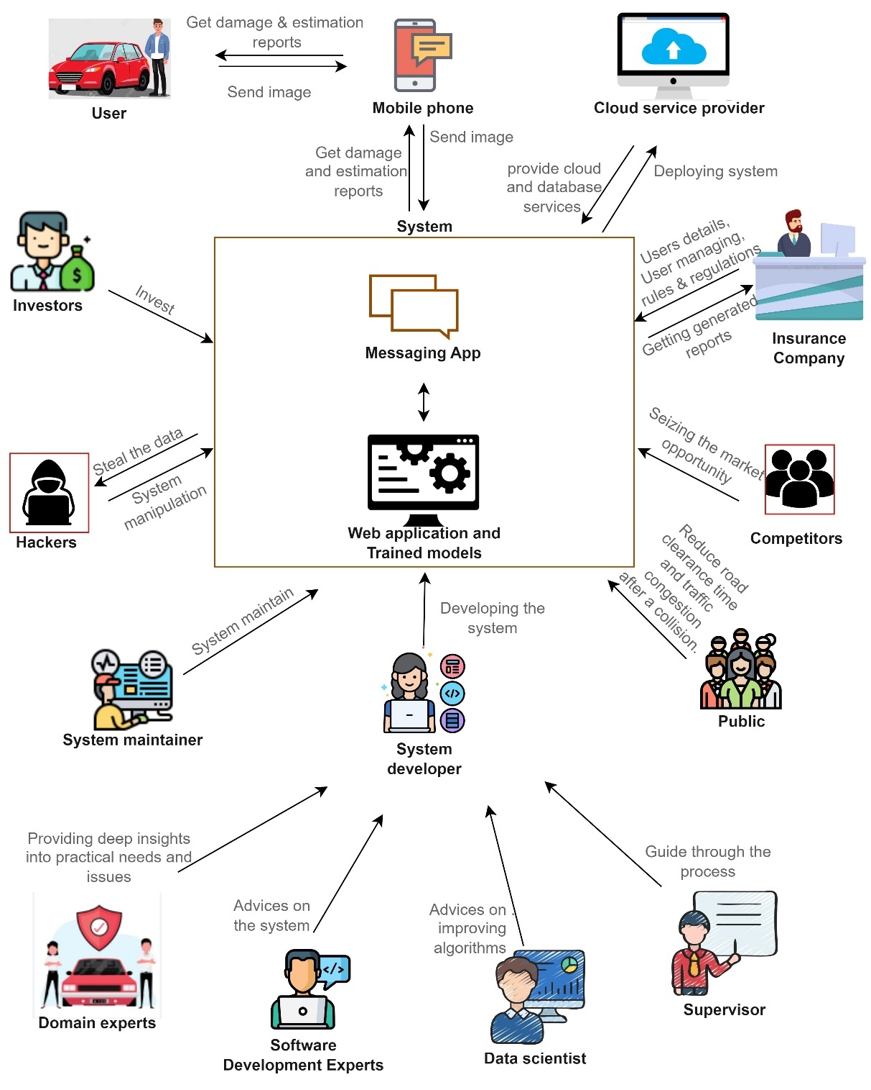

Figure - Rich Picture Diagram

## Stake Holder Analysis

### Stakeholder onion model

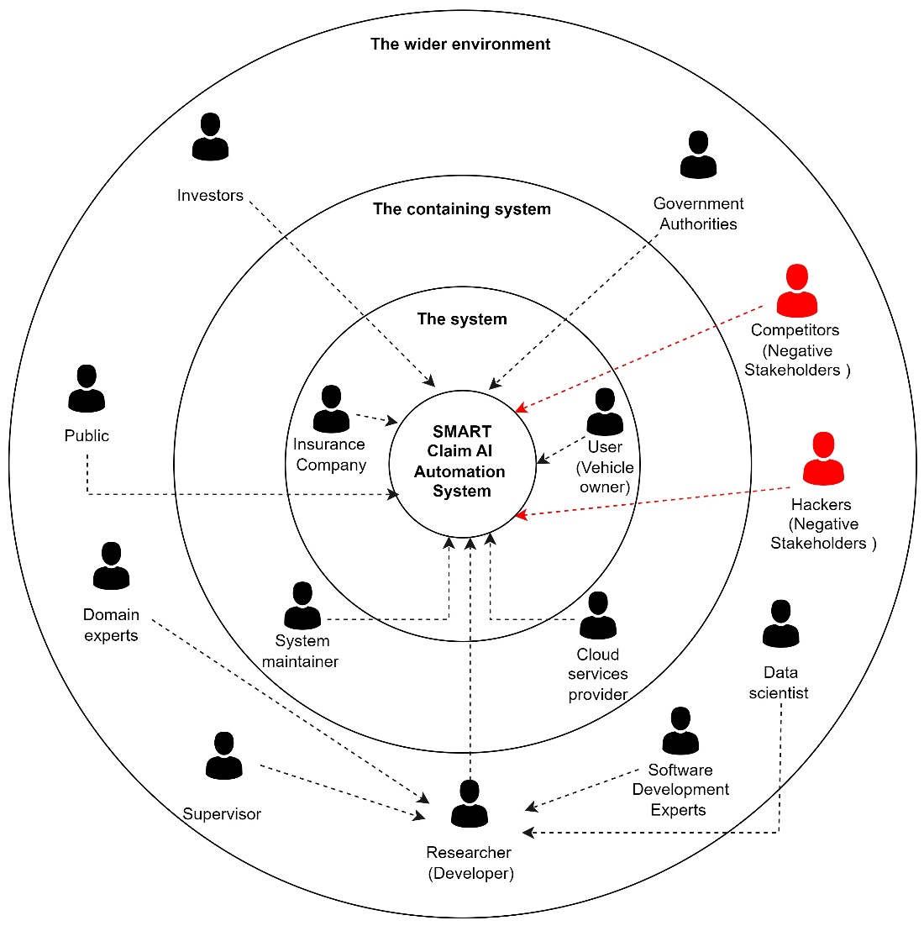

Figure - Stakeholder onion model

### Stakeholder Viewpoints

|  |  |  |  |  |  |  |  |  |  |  |  |
| --- | --- | --- | --- | --- | --- | --- | --- | --- | --- | --- | --- |
| **Stakeholder** | **Role** | | **Benefits** | | | | | | | | **Viewpoint** |
| The wider environment | | | | | | |  |  | | |  |
| Government authorities | Government authorities play a crucial role in regulating and overseeing the activities of insurance companies. They ensure that insurance companies follow proper protocols and regulations to provide a fair and just service to the public. | | The proposed system will benefit from the support and guidelines provided by the government authorities. This will enable it to operate within the legal and regulatory framework set by the government, which will help to ensure the credibility and reliability of the system. | | | | | | | | Government authorities are expected to have a keen interest in the system as it seeks to provide a fair and reliable service to the public. They expect the system to be in compliance with regulations and standards set by the government and to protect the rights of the public in its operations. |
| Public | The public are the end-users of the insurance services provided by the insurance company. They seek to receive fair and efficient services from the insurance company in case of any damage to their vehicle. | | The proposed system will provide a more accurate and efficient way for the public to report damage to their vehicle. This will save them time and effort compared to the traditional manual methods. | | | | | | | | The public is expected to be interested in the proposed system as it will simplify the process of reporting damage to their vehicle. They expect the system to be easy to use and provide accurate and reliable results. Reduce the time |
| Domain experts | Domain experts are individuals with a deep understanding of the insurance industry and the challenges it faces. They provide valuable insights and recommendations to improve the operations of insurance companies. | | The proposed system will benefit from the expertise and guidance of domain experts. They will provide valuable feedback on the system's performance and suggest ways to improve it. | | | | | | | | Domain experts are expected to have a keen interest in the proposed system as it seeks to improve the operations of insurance companies. They expect the system to be innovative, efficient, and in line with industry standards. |
| Competitors (negative stakeholders) | Competitors are other insurance companies providing similar services in the same market. They pose a challenge to the proposed system as they seek to maintain their market share and attract customers. | | The system will help the insurance company to differentiate itself from competitors by providing a more accurate and efficient service. This will help the company to attract more customers and increase its market share. | | | | | | | | Competitors are expected to view the proposed system with a critical eye as it may pose a threat to their market share. They expect the system to be reliable and provide a fair and efficient service to customers. |
| Hackers (negative stakeholders) | Hackers are individuals or groups who seek to access sensitive information or compromise the security of a system. They pose a threat to the proposed system as it handles sensitive information about customers and their vehicles. | | The proposed system will have robust security measures in place to protect sensitive information from hackers. This will help to ensure the confidentiality and privacy of customer information. | | | | | | | | Hackers are expected to view the proposed system as a challenge to their skills and seek to compromise its security. They expect the system to have robust security measures in place to protect sensitive information. |
| Software developer experts | Software developer experts are individuals with deep technical knowledge of software development and its best practices. They provide technical support and expertise in developing and maintaining software systems. | | The system will benefit from the technical support and expertise of software developer experts. They will ensure that the system is well designed, developed, and maintained to provide a reliable service to customers. | | | | | | | | expecting a system that utilizes their skills and is built with best practices and cutting-edge technology. |
| Investor | An investor is someone who provides financial resources to the project with the expectation of receiving a return on investment. They may also provide guidance and support in strategic decision-making. | | The investor provides financial support and expertise to the project, helping to fund research, development, marketing, and other operational costs, while accelerating growth and increasing the project's chances of success. | | | | | | | | The investor expects a profitable investment opportunity, with a clear and realistic plan for revenue generation and return on investment. They seek a strong team with relevant experience and a track record of success, and may also consider the potential impact of the system on the market and the community. |
| Researcher (developer) | Researchers play a crucial role in the development and implementation of the proposed system. They are responsible for conducting research and exploring new technologies and methods to improve the system. | | The proposed system will benefit from the research and exploration conducted by researchers, leading to new and innovative solutions. | | | | | | | | expecting a system that is continuously improving through research and development efforts. |
| The containing system | | | | |  |  | | | |  | |
| System maintainer | The system admin is responsible for maintaining and managing the proposed system. They ensure that the system is functioning properly and resolve any technical issues that may arise. | | The proposed system will benefit from the efficient management and maintenance provided by the system admin. | | | | | | | | expecting a system that is easy to manage and maintain with minimal technical issues. |
| The containing system | |  | |  | | | | |  | | |
| User | The user plays a crucial role in providing feedback and input on the proposed system. They are the end-users of the system and drive the demand for insurance services. | | The proposed system will provide an improved user experience in terms of efficiency and accuracy in damage assessment and claims processing. | | | | | | | | expecting an easy to use, efficient and accurate system that provides timely and fair claims processing. |
| Insurance company | The insurance company acts as the main user of the proposed system and is responsible for implementing and utilizing it in their day-to-day operations. | | The system will improve the efficiency and accuracy of the claims process, thereby reducing the workload and increasing customer satisfaction. The insurance company will also be able to streamline the entire process, saving time and resources. | | | | | | | | Expecting the proposed system to increase the speed and accuracy of the claims process, reduce manual errors and manual workload, and enhance overall customer satisfaction, leading to increased business growth and profitability. |

Table - Stakeholder Viewpoints

## Selection of Requirement Elicitation Methodologies

Requirements elicitation is an integral part of the requirements engineering process that focuses on identifying the needs of a system's users, customers, and stakeholders. While some may use the term "requirement gathering" to describe this process, the term "elicitation" emphasizes that obtaining high-quality requirements is more than just collecting information from customers. However, it can be challenging to elicit requirements since it's impossible to know for sure whether all of the requirements have been gathered from the user or customer simply by asking them about what the system should or should not do. The process starts with a review of existing literature and then proceeds to survey findings, interviews, and observations.

* **Formal Interviews with Insurance Agent:**

The researcher conducted formal interviews with insurance agent (with Mr. Prabath Amarasena From CO-OP Insurance Co Ltd.) and industry professionals to acquire insights into the gaps and improvements that could be addressed via the study. These interviews also helped to gather insights on the problem and potential solutions. Domain experts were also interviewed to gain a better understanding of the problem and its possible solutions.

* **Literature Review:**

Literature surveys were conducted to assess previous research and literature on the subject. The survey focused on what was previously known about the issue and what was still unknown to appreciate the value of new research and its connections to prior work.

* **Questionnaire/Survey:**

An online survey was conducted through Google Forms, which asked a series of structured questions to elicit useful information from respondents. This survey was shared with university students.

* **Observation**:

The researcher used observation to gather data for the project by immersing themselves in the environment where the subjects are located. They can observe their behavior and take notes or record their reactions, such as by watching, listening, reading, touching, or recording event behavior and features. For example, the researcher could observe users interacting with a software product to identify usability issues and gather insights.

* **Prototyping**:

A method for eliciting software requirements from stakeholders was proposed using prototyping, an agile software development technique. This method helped to identify technical and user experience issues, change criteria based on the discovered constraints, and identify new benchmarking measures. Few publications offer prescriptive counsel and demonstrate the practical application of this method.

* **Brainstorming**

The researcher used brainstorming as a technique to generate new and creative ideas for the development of an automation system for vehicle damage detection and cost estimation using computer vision. A group of experts in the field were gathered and encouraged to generate as many ideas as possible related to the topic. This approach helped the researcher to identify new and innovative solutions that may not have been thought of otherwise. The brainstorming sessions also brought together the different perspectives and expertise of the participants, leading to a more comprehensive and well-rounded understanding of the problem and potential solutions.

## Discussion of Findings

### Findings from Literature Review

|  |  |
| --- | --- |
| **Paper and Description** | **Findings** |
| **Vehicle Damage-Detection Segmentation Algorithm Based on Improved Mask RCNN (Zhang et al., 2020):**  Developed a detection algorithm for vehicle damage detection using deep learning to address compensation problems in traffic accidents.  Proposed a transfer learning and improved Mask RCNN-based vehicle damage detection method.  The improved method is more universal and adaptable to different aspects of car-damage images.  Data expansion is needed to increase the size of the dataset, collect more car damage images under different weather conditions and illumination levels, and improve the edge-contour enhancement and masking accuracy of damaged areas. | The authors proposed a transfer-learning and improved Mask RCNN-based vehicle damage detection method for handling compensation problems in traffic accidents. The proposed method was found to be more universal and adaptable to various aspects of car damage images. However, the authors suggested the need for data expansion to increase the size of the dataset and improve the accuracy of the masking of the damaged areas of the car. |
| **A Very Deep Transfer Learning Model for Vehicle Damage Detection and Localization" (Dhieb et al., 2019)**  Proposed a novel framework for detecting, locating, and identifying damage severity on vehicles using CNN, transfer learning, and Mask R-CNN techniques.  Used Inception-Resnet pre-trained model as feature extractor.  Method can detect damage and identify severity of damage. | The authors proposed a novel framework for detecting, locating, and identifying damage severity on vehicles using CNN, transfer learning, and Mask R-CNN techniques. Their approach could detect the damage and identify the severity of the damage. They used the Inception-Resnet pre-trained model for feature extraction. |
| **Image Processing based Severity and Cost Prediction of Damages in the Vehicle Body: A Computational Intelligence Approach" (Harshani and Vidanage, 2017):**  Focused on damage detection and cost estimation of damage repair.  Used pre-defined labels for minor, moderate, and severe damage.  Used Scale Invariant feature extraction method for feature extraction and SVM for classification.  Dataset consisted of localized damaged areas, not suitable for images from a distance. | The authors proposed a damage detection and cost estimation method that used a pre-defined classification system based on three labels: Minor, Moderate, and Severe. They used a Scare Invariant feature extraction method for feature extraction and an SVM for classification. However, the approach was limited to localized damaged areas and was not suitable for images from relatively big distances. |
| **Machine Learning for Predicting the Damaged Parts of a Low Speed Vehicle Crash" (Koch et al., 2018):**  Focused on low-speed vehicle crash, defined as velocity difference of 16 kmph  Used tfresh algorithm for feature extraction.  Limited size of train dataset, used ensemble learning method to optimize extracted features. | The authors proposed a machine learning-based approach for predicting the damaged parts of a low-speed vehicle crash. They used the tfresh algorithm for feature extraction and an ensemble learning method due to the limited size of the train dataset. However, the approach's scope was limited to low-speed vehicle crashes. |
| **The design of glass crack detection system based on image preprocessing technology. (Zhang, 2014)**  Focused on glass crack calculation.  Compared different methods for image smoothing filtering, image sharpening, and image segmentation. | This paper focused on glass crack calculation and compared different methods for image smoothing filtering, image sharpening, and image segmentation using algorithms to calculate the crack of the glass. |
| **Image-based Retrieval of Concrete Crack Properties. (Adhikari, Moselhi and Bagchi):**  Used risk-based approach in concrete structure inspection.  Used image stitching algorithm for multiple images on the same crack.  Used spatial domain operation for mask processing, histogram-based techniques for visualization enhancement, and binary image thinning to obtain image skeleton. | The authors used a risk-based approach for concrete structure inspection using multiple images on the same crack. They used an image stitching algorithm developed by Brown and Lowe (2007), spatial domain operation for mask processing, frequency domain method for crack detection, histogram-based techniques for preprocessing, and binary image thinning to obtain the image's skeleton. The approach used morphological techniques such as dilation to maintain connectedness. |
| **Fast Image Segmentation Using Two Dimensional Otsu Based on Estimation of Distribution Algorithm (Wang, Duan and Wang, 2017):**  Classic Otsu method is limited if applied to non-even lighting.  2D Otsu method adds another dimension to the original one to address non-even lighting issue. | This paper proposed a 2D Otsu method to overcome the limitations of the classic Otsu method when applied to images with non-even lighting. |
| **An improved grey wolf optimizer based on differential evolution and OTSU algorithm. (Liu et al., 2020)**  Proposed method more accurate than 2D Otsu method. | This paper proposed a method that could provide more accurate results than the 2D Otsu method for image segmentation. |
| **Car Damage Detection and Classification" (Kyu and Woraratpanya, 2020):**  Described various deep learning based algorithms for car damage detection  Small datasets were insufficient, transfer learning had better results than fine tuning  Used pre-trained VGG models to detect damaged parts, location, and severity  Proposed model faced overfitting problem, future work aims to utilize other regularization techniques and pre-trained CNN models with a large dataset. | The authors proposed various deep learning-based algorithms for car damage detection, and they found that small datasets were insufficient. |

Table - Findings from Literature Review

### Findings from Survey / Questionnaire

|  |  |  |
| --- | --- | --- |
| **Question 1** | Have you ever seen someone waiting for an insurance agent`s presence after an accident? Or have you gone through that experience yourself? | |
| **Aim** | To understand the frequency of accidents among people who travel in vehicles. | |
|  | |  |
| **Observations** | 155 people responded to the question, out of which 92.3% of people had encountered an accident while traveling. | |
| **Conclusion** | The majority of people who travel in vehicles have a high chance of encountering an accident. | |

|  |  |  |
| --- | --- | --- |
| **Question 2** | If you were in such a situation, how long did it take the insurance agent to reach ? | |
| **Aim** | To understand the time taken by the insurance agent to arrive at the accident location. | |
|  | |  |
| **Observations** | 152 people responded to the question, and 40.1% of people had to wait for 1-2 hours for the insurance agent to arrive. | |
| **Conclusion** | The waiting time for the insurance agent to arrive is relatively long, with 40.1% of people waiting for 1-2 hours. | |

|  |  |  |
| --- | --- | --- |
| **Question 3** | How satisfied were you with the waiting time till the insurance agent arrives ? | |
| **Aim** | To understand the level of satisfaction of people with the waiting time for the insurance agent to arrive. | |
|  | |  |
| **Observations** | 153 people responded to the question, and 67.3% of people were either dissatisfied or very dissatisfied with the waiting time. | |
| **Conclusion** | Most people are dissatisfied with the waiting time for the insurance agent to arrive after an accident. | |

|  |  |  |
| --- | --- | --- |
| **Question 4** | How long did it take to clear the road after the accident? | |
| **Aim** | To understand the time taken to clear the road after the accident | |
| Chart of responses – Refer to appendix | |  |
| **Observations** | 153 people responded to the question, and 36.6% of people had to wait for 1-2 hours to clear the road. | |
| **Conclusion** | The time taken to clear the road after an accident is relatively long, with 36.6% of people waiting for 1-2 hours. | |

|  |  |  |
| --- | --- | --- |
| **Question 5** | Do you think, using an automated system for damage estimation would save time in the insurance claim process, including the waiting time for the insurance agent? | |
| **Aim** | To understand the opinion of people on using an automated system for damage estimation in the insurance claim process. | |
| Chart of responses – Refer to appendix | |  |
| **Observations** | 153 people responded to the question, and 85.6% of people believe that using an automated system for damage estimation would save time in the insurance claim process. | |
| **Conclusion** | The majority of people think that using an automated system for damage estimation will save time in the insurance claim process. | |

|  |  |  |
| --- | --- | --- |
| **Question 6** | How satisfied will you be, if you get a detailed report on the damage estimation and repair parts that are going to be repaired in your vehicle via mobile? | |
| **Aim** | To understand the level of satisfaction of people with receiving a detailed report on the damage estimation and repair parts via mobile. | |
| Chart of responses – Refer to appendix | |  |
| **Observations** | 153 people responded to the question, and 86.2% of people were satisfied or extremely satisfied with receiving a detailed report on the damage estimation and repair parts via mobile. | |
| **Conclusion** | The majority of people are satisfied with receiving a detailed report on the damage estimation and repair parts via mobile. | |

|  |  |  |
| --- | --- | --- |
| **Question 7** | Would you like to be able to get repair cost estimates for the damages found on vehicle? | |
| **Aim** | This question aims to determine the respondents' interest in receiving repair cost estimates for damages found on their vehicle. | |
| Chart of responses – Refer to appendix | |  |
| **Observations** | The majority of the respondents, 87.7%, expressed their interest in receiving repair cost estimates for damages found on their vehicle. Only 7.8% respondents showed no interest, and 4.5% were uncertain. | |
| **Conclusion** | The results show that the majority of respondents would appreciate having repair cost estimates for damages found on their vehicle. This suggests that incorporating repair cost estimates in the proposed system could enhance its overall value. | |

|  |  |  |
| --- | --- | --- |
| **Question 8** | Are there any specific types of damage that you are particularly concerned about (e.g. dents, cracks, etc.)? | |
| **Aim** | This question aims to gather information about the specific types of damages that respondents are more concerned about when it comes to their vehicle. | |
| Chart of responses – Refer to appendix | |  |
| **Observations** | Respondents' answers varied and included dents, cracks, dents that require welded pulling, and dents that needed to be corrected through body fillers, and cracks that need to be re-fibered. | |
| **Conclusion** | The results indicate that respondents have different areas of concern when it comes to the type of damage they might encounter on their vehicle. Therefore, the proposed system must be able to detect and provide estimates for various types of damages. | |

|  |  |  |
| --- | --- | --- |
| **Question 9** | Do you have any specific requirements for this system ? | |
| **Aim** | This question aims to gather information about any specific requirements that respondents may have for the proposed system. | |
| Responses – Refer to appendix | |  |
| **Observations** | Respondents' answers included requirements for an easy-to-use interface, clear and detailed damage reports, and user-friendly mobile applications. | |
| **Conclusion** | The results suggest that users prioritize convenience and ease of use in the proposed system. Therefore, it is essential to keep these requirements in mind while designing the system. | |

|  |  |  |
| --- | --- | --- |
| **Question 10** | Have you ever heard of or used a solution (app/website) that can detect vehicle damage by uploading images? | |
| **Aim** | This question aims to assess the level of respondents' awareness regarding the availability of solutions that can detect vehicle damage by uploading images. | |
| Chart of responses – Refer to appendix | |  |
| **Observations** | The majority of respondents, 90.4%, reported that they had not heard of or used any app/website that could detect vehicle damage by uploading images. | |
| **Conclusion** | The results suggest that there is an opportunity for the proposed system to offer a unique solution to the current problem of waiting for an insurance agent's presence after an accident. It also highlights the need for appropriate marketing strategies to promote the system and make it more accessible to potential users. | |

|  |  |  |
| --- | --- | --- |
| **Question 11** | If yes what is the name of the solution? | |
| **Aim** | This question aims to gather information about any app/website that respondents may have used to detect vehicle damage by uploading images. | |
| Chart of responses – Refer to appendix | |  |
| **Observations** | Out of the 146 respondents who answered the previous question, only 33 respondents (22.6%) mentioned using a solution, with geico.com being the only named solution. | |
| **Conclusion** | The results suggest that solutions that can detect vehicle damage by uploading images are not well-known or widely used. Therefore, the proposed system has an opportunity to fill this gap in the market and provide a unique solution to users' needs. | |

Table - Findings from Survey / Questionnaire

### Findings from Formal Interviews with The Insurance Agent

|  |  |  |
| --- | --- | --- |
| **Question** | **Answer** | **Findings** |
| Can you describe your current process for assessing and estimating vehicle damage for insurance claims? | Our current process involves an insurance adjuster physically inspecting the vehicle, documenting the damage, and using industry tools and guides to estimate the repair cost. | The current process for assessing and estimating vehicle damage for insurance claims involves an insurance adjuster physically inspecting the vehicle, documenting the damage, and using industry tools and guides to estimate the repair cost. |
| What are some of the challenges and bottlenecks you encounter with this process? | One of the main challenges is that it can be time-consuming and resource-intensive to send an adjuster to every damage claim. Additionally, there can be inconsistencies in the accuracy of damage assessments between different adjusters. | The main challenges with this process are that it can be time-consuming and resource-intensive to send an adjuster to every damage claim, and there can be inconsistencies in the accuracy of damage assessments between different adjusters. |
| Are there any tools or technologies you currently use to aid in the vehicle damage assessment process? | We use industry guides and software tools to help estimate repair costs, but we do not currently use any technology specifically designed for damage assessment. | The insurance agent currently uses industry guides and software tools to aid in the vehicle damage assessment process, but does not currently use any technology specifically designed for damage assessment. |
| How accurate do you need the damage assessment to be, and what factors impact this accuracy? | Accuracy is very important for us, as it directly affects the amount of compensation we provide to policyholders. Factors that impact accuracy include the skill of the assessor and the quality of the information used to estimate repair costs. | Accuracy is crucial in the damage assessment process as it directly affects the compensation provided to policyholders. Factors that impact accuracy include the skill of the assessor and the quality of the information used to estimate repair costs. |
| How quickly do you need the damage assessment to be completed, and what factors impact the speed of the assessment? | Quick turnaround time is important to us, as it helps minimize inconvenience for policyholders and improve customer satisfaction. Factors that impact the speed of the assessment include the availability of adjusters, the complexity of the damage, and the efficiency of the assessment tools. | Quick turnaround time is essential in minimizing inconvenience for policyholders and improving customer satisfaction. Factors that impact the speed of the assessment include the availability of adjusters, the complexity of the damage, and the efficiency of the assessment tools. |
| Are there any specific types of damage that you would like the system to be able to detect (e.g. dents, cracks, etc.)? | We would like the system to be able to detect all types of damage, including dents, cracks, and any other visible damage to the exterior and interior of the vehicle. | The insurance agent would like the system to be able to detect all types of damage, including dents, cracks, and any other visible damage to the exterior and interior of the vehicle. |
| What kind of information would you like the system to provide about the damage (e.g. location, severity, repair cost estimate, etc.)? | We would like the system to provide a comprehensive report on the location, severity, and estimated repair cost of the damage. | The insurance agent would like the system to provide a comprehensive report on the location, severity, and estimated repair cost of the damage. |
| How would you like the information from the system to be delivered to you (e.g. email, mobile app, web portal, etc.)? | We prefer to receive the information through a web portal, where it can be easily accessed by our adjusters and claims team. | The preferred delivery method for the information is through a web portal that can be easily accessed by adjusters and the claims team. |
| Would you be interested in integrating the system with your existing systems and processes? | Yes, we would be interested in integrating the system with our existing claims management system to streamline the damage assessment process. | The insurance agent is interested in integrating the system with their existing claims management system to streamline the damage assessment process. |
| What is your budget for such a system, and what is the timeline for implementation? | Our budget for such a system is flexible, and we are open to exploring different options. Our timeline for implementation would depend on the availability of the system and the time required for integration with our existing systems. | The budget for the system is flexible, and the timeline for implementation depends on the availability of the system and the time required for integration with their existing systems. |

Table - Findings from Formal Interviews with The Insurance Agent

### Findings from Observation

During the observation of the existing vehicle damage detection and cost estimation process, it was found that it is a time-consuming and tedious task that requires a lot of human effort. The current process relies heavily on the expertise of the inspector to detect and estimate the damage, which may lead to errors and inconsistencies in the process. Moreover, the current process lacks the ability to provide real-time information to the customer, resulting in delayed responses and increased wait times.

### Findings from Brainstorming

The brainstorming session aimed to identify potential solutions to the problems identified during the observation phase. Through the brainstorming process, it was concluded that implementing an automation system that uses computer vision technology would be an efficient and effective solution. The proposed system would rely on cameras mounted on inspection bays that capture images of the vehicles from different angles, which would then be processed using computer vision algorithms. The system would be capable of detecting and classifying various types of damages, including dents, scratches, and cracks, and estimating the cost of repairs based on the severity of the damage. The system would also be able to provide real-time feedback to the customer, allowing for immediate action to be taken, such as scheduling repairs and providing cost estimates.

In conclusion, the proposed automation system for vehicle damage detection and cost estimation would revolutionize the current process by eliminating human error and providing real-time information to customers. The system would improve the efficiency of the process, reduce wait times, and increase customer satisfaction. Additionally, the implementation of the proposed system would reduce the workload of inspectors, freeing up their time to focus on other tasks. Overall, the proposed system is a much-needed upgrade to the existing process and would benefit all stakeholders involved.

### Summary of Findings

1 - Literature Review | 2 - Survey | 3 – Interview | 4 – Brainstorming | 5 - Observation

|  |  |  |  |  |  |
| --- | --- | --- | --- | --- | --- |
| **Finding** | **1** | **2** | **3** | **4** | **5** |
| The current process of vehicle damage detection and cost estimation is time-consuming and resource-intensive. | x |  | x | x |  |
| Customers are dissatisfied with the waiting time for insurance agents to arrive after an accident |  | x |  | x | x |
| The majority of people think that using an automated system for damage estimation will save time in the insurance claim process. |  | x |  | x | x |
| Users prioritize convenience and ease of use in the proposed system. |  | x |  | x | x |
| The proposed system must be able to detect and provide estimates for various types of damages. | x |  | x |  |  |
| Incorporating repair cost estimates in the proposed system could enhance its overall value. |  | x | x |  |  |
| The insurance agent wants the system to detect all types of damage and provide a comprehensive report on the location, severity, and estimated repair cost of the damage. | x | x | x |  |  |
| The preferred delivery method for the information is through a web portal that can be easily accessed by adjusters and the claims team. |  | x | x | x |  |
| Accuracy and quick turnaround time are essential in the damage assessment process. | x |  | x |  |  |
| System has an opportunity to fill gap in the market and provide a unique solution to users' needs. |  |  | x | x | x |

## Context diagram

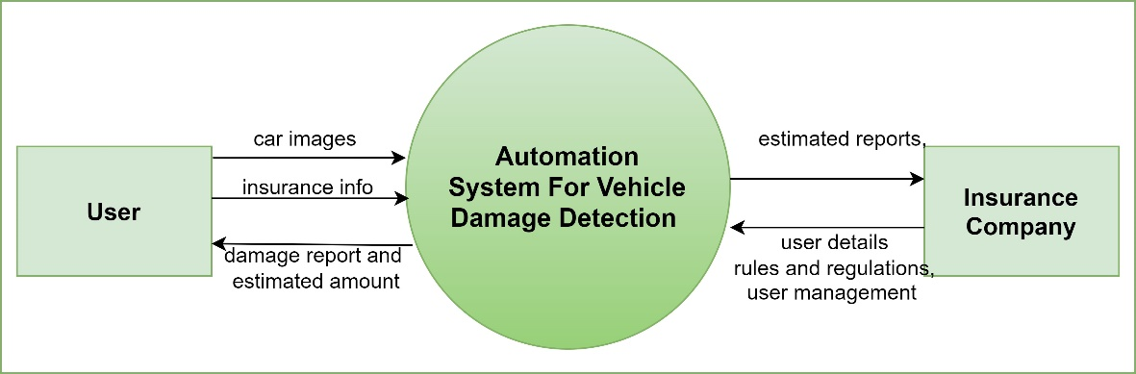

Figure - Context Diagram

## Use case Diagram

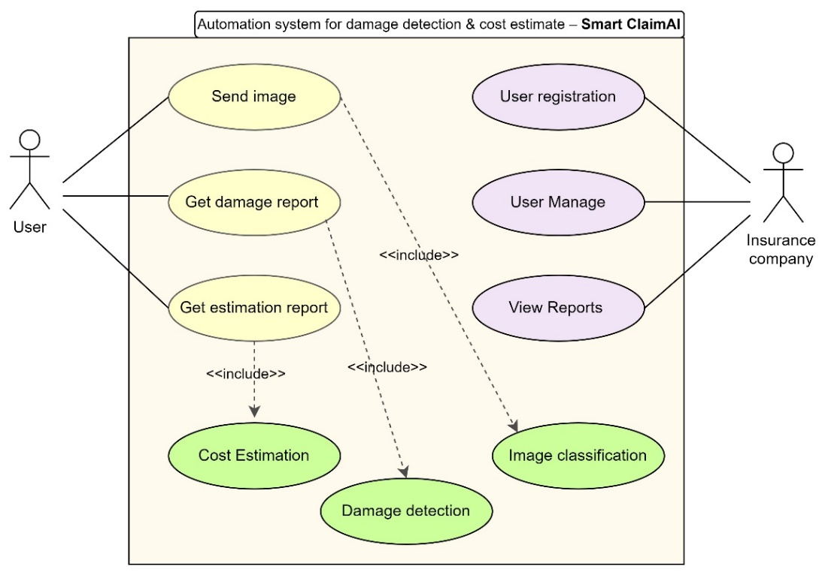

Figure - Use case diagram

## Use case descriptions.

|  |  |  |  |
| --- | --- | --- | --- |
| Use case | Send Image | Use case ID | 01 |
| Description | Allows the user to upload an image of the damaged vehicle to the Smart Claim AI system. | | |
| Primary actor | User | Support actor | Smart Claim AI system |
| Pre-condition | User has access to the Smart Claim AI system and has a damaged vehicle to report. | | |
| Post-condition | The system receives the uploaded image for further analysis. | | |
| Initial step | User requests to upload an image of the damaged vehicle. | | |
| Main Success  scenario | The user navigates to the image upload section of the system.  The user selects the damaged vehicle image to upload.  The system receives the uploaded image and stores it for further analysis.  Variations -  If the user uploads an invalid image format, the system prompts the user to upload a valid image or provides an error message.  If the uploaded image is of poor quality, the system prompts the user to upload a higher quality image or provides an error message. | | |

Table - Use case description

( Other use case descriptions  - Please refer to appendix)

## Requirements

|  |  |  |
| --- | --- | --- |
| **Priority Level** | **MoSCoW Principle** | **Description** |
| Critical | Must have | This category includes the core functionalities of the system that are essential for its successful implementation. These requirements are critical and must be included in the system to ensure its basic functionality. Failure to include any of these requirements may result in the failure of the entire system. |
| Important | Should have | These requirements are necessary to achieve the core functionalities of the system. They are important and should be included in the system to provide an optimal user experience. Although not critical, failure to include any of these requirements may hinder the system's performance and its ability to meet its objectives. |
| Desirable | Could have | These functionalities are not essential to the core functionality of the system, but they would enhance the user experience and add value to the overall system. They are good to have, and their inclusion in the system would be beneficial, but their absence would not hinder the system's basic functionality. |
| Non-essential | Won’t have | These functionalities are not crucial to the success of the system and are not included in the initial prototype. They can be added in future iterations or updates, but they are not necessary for the core functionalities of the system. While they may provide added value, their absence does not affect the basic functionality of the system. |

Table – Requirements description

### Functional Requirements

The proposed system's functional requirements are prioritized and listed in the table below, highlighting the key product features and functions that must be developed by the development team to enable users to complete their tasks. These functional requirements play a critical role in the system's success and must be communicated clearly to all stakeholders to ensure that they are fully understood.

|  |  |  |  |
| --- | --- | --- | --- |
| # | **Requirement type and Description** | **Priority** | **Related Use Case** |
| FR1 | **Send multiple image of the damaged car:** The user should be able to upload multiple images of the damaged car for analysis. | Must have | Send images |
| FR2 | **Object detection:** The system's model must be able to extract the location of damage and severity from the image. | Must have | Detection |
| FR3 | **Creating a quality labeled dataset:** The author should create a quality labeled dataset to improve the accuracy of the pre-trained model. | Should have | Model train |
| FR4 | **View history:** The system should manage a database to store the user's prediction results, allowing users to view their past results. | Should have | View history |
| FR5 | **User login:** The user should be able to log in to the system using secure credentials. | Won’t have | User authentication |
| FR6 | **Filter vehicle damages:** The system should be able to filter out irrelevant vehicle damages and focus on the actual damage. | Could have | Classifying images |
| FR7 | **Identify severe vehicle damages:** The system should be able to identify severe vehicle damages that require immediate attention. | Must have | Detecting damage |
| FR8 | **Get latest price of damaged components:** The system should retrieve the latest price of the damaged components from reliable sources. | Could have | Calculate damage |
| FR9 | **Estimate damage cost:** The system should be able to estimate the cost of vehicle damage accurately based on the identified damages and the latest prices of the components. | Must have | Estimate cost |

Table - Functional Requirements

### Non-Functional Requirements

The non-functional requirements of the system, which define the characteristics and properties that are not directly related to the system's functionality, are also important. These requirements, prioritized according to user needs, include security, accuracy, performance, reliability, maintainability, and usability. They act as constraints and limitations on how the system is developed throughout the project's backlogs, ensuring that it meets the quality and flow standards that are essential to its success. By adhering to these non-functional requirements, the system will provide an enhanced user experience, leading to higher user satisfaction and system efficiency.

|  |  |  |
| --- | --- | --- |
| **#** | **Requirement title and Description** | **Priority Level** |
| NFR1 | **Accuracy:** The system should be able to analyze images and provide damage estimation accurately. The accuracy of the system is critical for ensuring that users can rely on the damage estimation results. | Must have |
| NFR2 | **Performance:** The system should be able to respond within 1 minute after requesting a damage estimation. The prediction model should maintain a balance between accuracy and prediction speed to ensure that users can receive fast and accurate results. | Must have |
| NFR3 | **Usability:** The user interaction with the UI of the application should be minimal, with a simple UI to upload images and a graphical view to show damage estimation and details of the components. The system should be intuitive and easy to use, requiring minimal training for users. | Could have |
| NFR4 | **Security:** The system should have a user authentication system to ensure that only authorized users can access the application. The user data should be secure and protected from unauthorized access. | Must have |
| NFR5 | **Reliability:** The servers should always be functional to ensure that users can access the system at any time. The system should be reliable and available, with minimal downtime. | Should have |
| NFR6 | **Maintainability:** The system should be created in a way that security patches and updates can be given easily for the web application. The system should be maintainable, with clear documentation and modular design to make updates and maintenance tasks easier to perform. | Could have |

Table - Non-Functional Requirements

## Chapter Summary

This chapter begins with a rich picture diagram, giving an overview of stakeholders, their concerns, and the proposed solution. Stakeholder analysis is presented, identifying stakeholders and their interests in the system. The stakeholder onion model and viewpoints provide a comprehensive understanding of requirements. The selection of requirement elicitation methodologies describes the various methods used.

The discussion of findings section summarizes the results obtained from the requirement elicitation methodologies, including findings from literature review, surveys, interviews, observation, and brainstorming. The context diagram and use case diagram provide a graphical representation of the system and its functions. The use case descriptions section elaborates on the use cases, providing a detailed description of each use case. The chapter concludes with the definition of functional and non-functional requirements of the system, including the software and hardware requirements, performance requirements, and usability requirements. Overall, this chapter provides a comprehensive understanding of the system's requirements and lays the foundation for the development of the system.

# Chapter 03: DESIGN

## Chapter overview

The Design chapter of this project focuses on the various design aspects of the proposed system. The chapter outlines the design goals and objectives, the high-level design, and the architecture diagram. It also provides a discussion on the different tiers of the architecture and the low-level design. Additionally, the chapter explores the choice of design paradigm, data flow diagrams, and the design diagrams, including the component diagram and system process flow chart. Finally, it presents the user interface design of the proposed system.

## Design Goals

The design goal of this project is to create an automated machine learning system that can perform vehicle damage detection and cost estimation using computer vision technology. The system should be designed with various key factors in mind, including security and privacy, scalability, performance, high availability, correctness, reusability, flexibility, efficiency, adaptability, accuracy, user experience, functionality, maintainability, and cost-effectiveness.

|  |
| --- |
| **Security and Privacy:** Incorporating access control measures in the system to prohibit unauthorized access to resources and data. Ensuring that data is encrypted when it is accessible via the file system or is viewable across a network. Maintaining confidential user data in a highly secure environment is a critical requirement for the system. The privacy measures should also be consistent with the General Data Protection Regulation (GDPR). |
| **Scalability:** Designing the system to be easily scalable by allowing developers to add more enhancement algorithms and classifiers in the future. The basic architecture and main backbone of the system should work well even when handling large datasets and complex algorithms. The system should be able to add new algorithms and preprocessing steps without much tweaking. |
| **Performance:** Designing the system to automatically build several ML models at the same time to improve performance. The system should be able to make use of computing power efficiently and produce goods of a predefined quality at a fast speed. The system should be performance-oriented to ensure that processing latencies are kept to a minimum, and it should be able to dynamically alter its processing performance by changing the available computing resources and scheduling algorithms on the fly. |
| **High Availability:** Designing the system to operate continuously without failure for a specified amount of time, referred to as high availability. The system should reach an agreed-upon operational performance standard, and availability standards such as five-nines availability in information technology (IT) should be considered. |
| **Correctness:** Designing the system to make the machine learning process automated and easy for novices to perform. The system should be able to build machine learning models, and novice developers should find it easy to use the system. |
| **Reusability:** Designing the system with modularity in mind, so that its components can be re-used in extensions or other developments. The code of a well-designed system should be able to apply to similar projects. |
| **Flexibility:** Designing the system to be flexible enough to adapt to changes in requirements during the implementation stage. The system should be able to easily adopt new user features and support a variety of different data processing contexts. It should also be adaptable to a range of different devices. |
| **Efficiency:** Designing the system to make the greatest use of the available memory, processing power, and network speed. |
| **Adaptability:** Designing the system to be easily adaptable to new user features, and new extensions should be easily plugged in to the core product. The system should be capable of processing data on many peer devices at the same time, and the client application should support a wide range of devices, independent of their specifications. |
| **Accuracy:** Ensuring that accuracy is one of the highest priorities of the project and designing the system not to adversely affect accuracy. |
| **User Experience:** Designing the project to be user-friendly and easy to use for the intended audience. |
| **Functionality:** Ensuring the project functions as intended and meets the requirements of its stakeholders. |
| **Maintainability:** Designing the project to be easily maintainable and updatable to ensure it remains relevant and effective over time. |
| **Cost-effectiveness:** Designing the project to be cost-effective while still meeting the needs of its stakeholders. |

Table - Design Goals

## High level Design

### Architecture Diagram

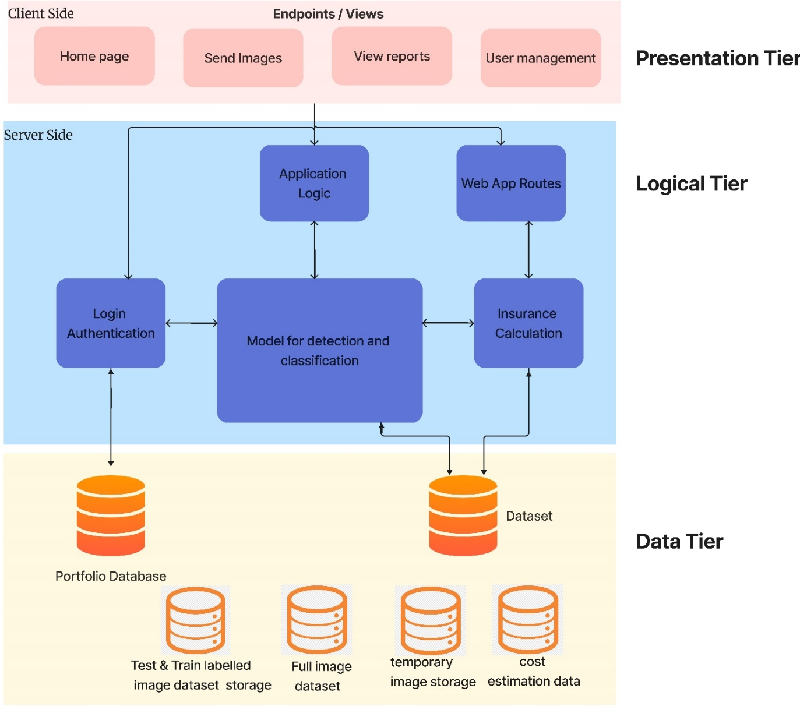

Figure - Architecture Diagram

### Discussion of tiers of the Architecture

**Tiered Architecture –**

The depicted system architecture follows a three-tier model, consisting of a data tier, a logic tier, and a presentation tier. While the presentation and data tiers are primarily application-focused, the logical tier is where the research's principal contribution lies. The architecture prioritizes modularity, with the three tiers reflecting the Python system on which it is based. It adheres to the three-tier architecture style with data, logic, and presentation layers, emphasizing the logical tier's significance while the other layers are application-driven. The architecture employs a modular approach to adhere to several software engineering principles, including coupling, cohesiveness, adaptability, scalability, reusability, and separation of concerns. The data tier manages data and database interactions, the logic tier contains the application logic, and the presentation tier presents the processed data to the user in a suitable format.

**1. Data Tier**

a. Full image Dataset Storage - This tier stores the complete set of images that have been used for testing and training purposes. The dataset is accessed online.

b. Test & Train split labeled image dataset storage - This tier stores the dataset that has been split into test and train images. The images are labeled for easy access.

c. Temporary image storage - This tier is not online, and it stores images locally on the user's device. Images are deleted after prediction, and the purpose is to provide a backup after each significant step of prediction.

d. Cost estimation data - This tier stores estimation data. e. Portfolio database - This tier stores the user's details.

**2. Logic Tier**

a. Login authentication - This tier provides the login authentication mechanism.

b. Application logic - This tier includes the primary logic that controls the functioning of the entire system.

c. Web app routes - This tier handles the web app's routing system.

d. Model for detection and Classification - This tier includes the model that has been developed for detection and classification.

e. Insurance calculation - This tier includes the logic for calculating insurance costs.

**3. Presentation Tier**

a. Home page - This tier includes the primary landing page for the web app.

b. Send Images - This tier allows the user to upload and send images for analysis.

c. View reports - This tier allows the user to view the analysis reports generated by the system. d. User management - This tier includes the user management mechanism.

## Low-level Design

### Choice of design paradigm

The choice between design paradigms, specifically between SSADM and OOA, was based on several factors. In this case, SSADM was selected due to the well-defined and static user requirements, as well as the use of Python as the primary programming language, which aligns with the SSADM approach. Additionally, with a project timeline of less than a year, SSADM's document-led and manageable component approach will help ensure timely planning, analysis, design, and implementation of the prototype. Overall, SSADM's waterfall methodology provides a rigorous and structured approach to information systems analysis and design, making it a suitable choice for this project.

### Data flow diagram level 1

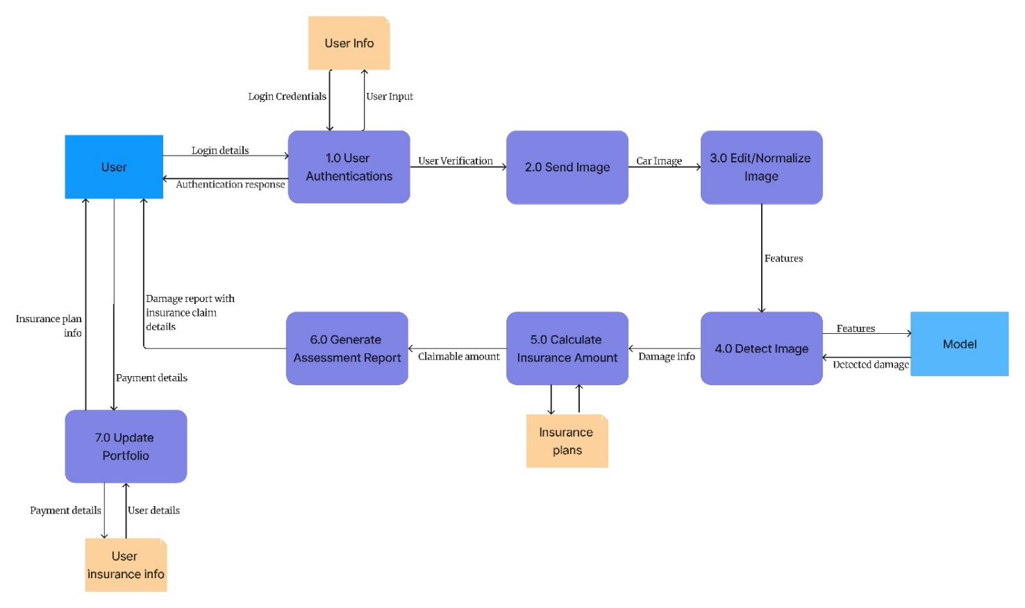

Figure - Data flow diagram level 1

Sequence Diagram – Please refer to appendix.

## Design Diagrams

### Component Diagram

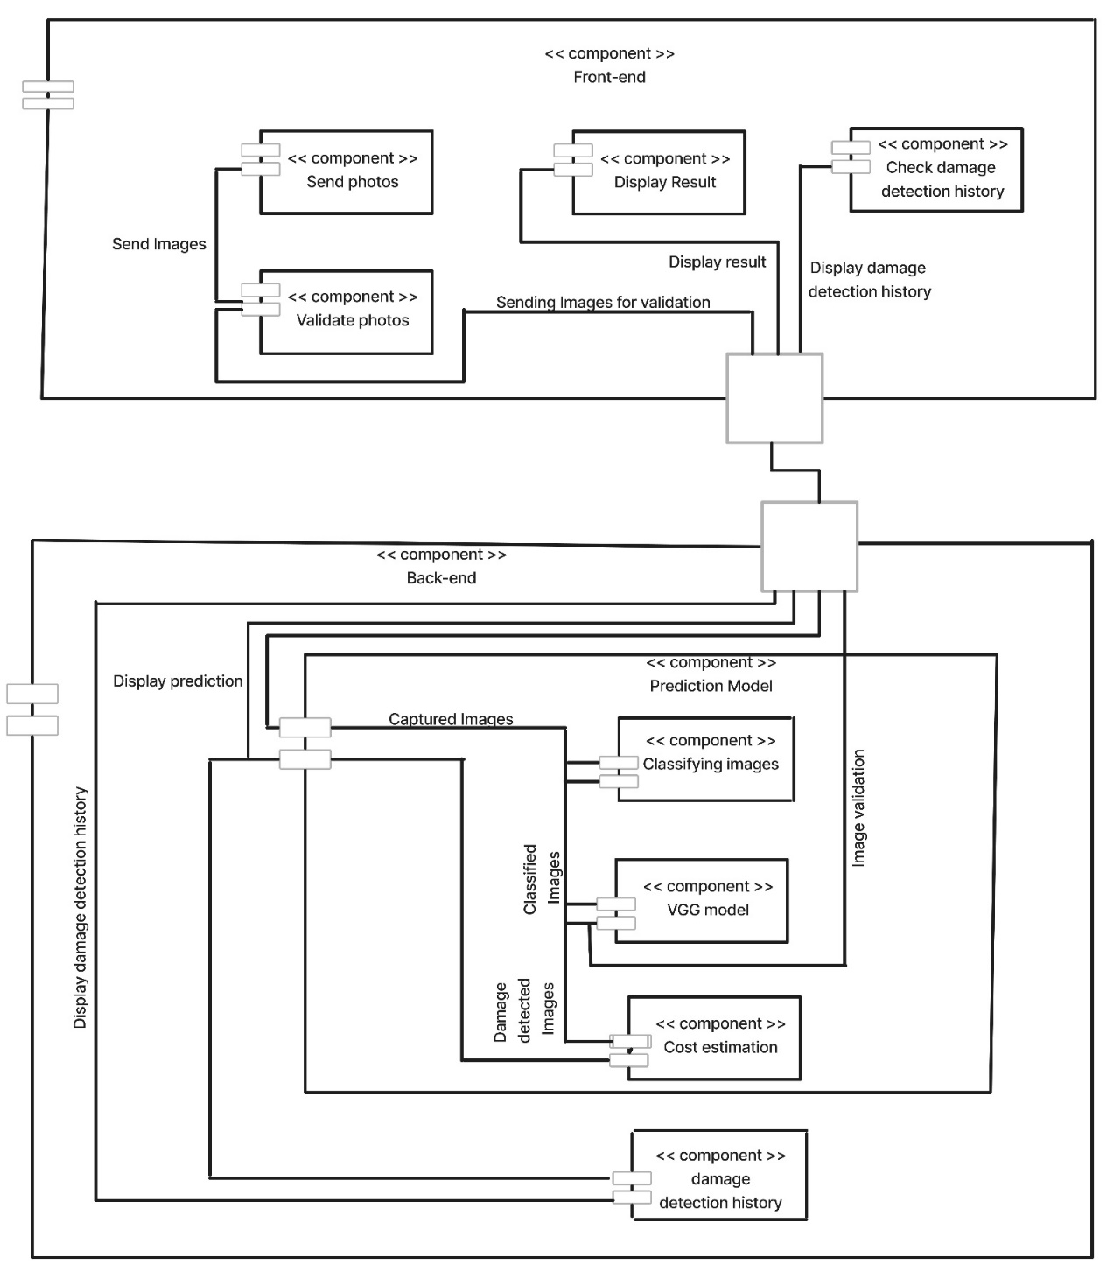

Figure - Component Diagram

### System Process Flow Chart

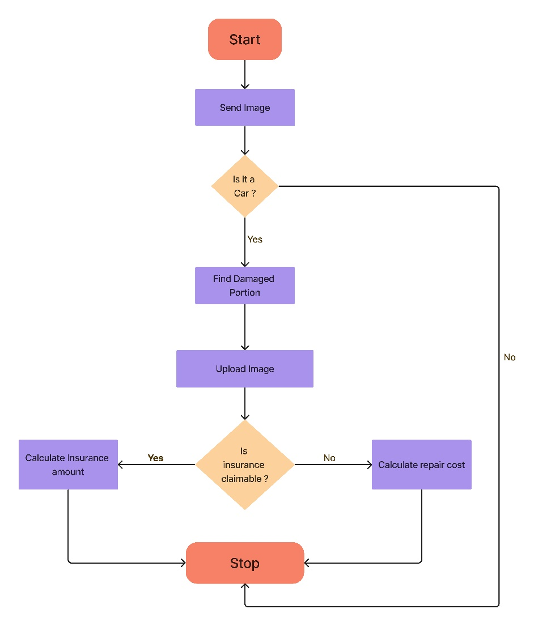

Figure - System flow chart

### User Interface Design



Figure - User Interface Design

## Chapter summary

This chapter focuses on the design phase of the project, outlining the goals and presenting the high and low-level designs for the proposed system. The chapter discusses the chosen design paradigm, data flow diagram, and architecture diagram, providing an overview of the system's structure and its various components. The chapter also includes design diagrams such as the component diagram and system process flow chart, as well as the user interface design. By the end of this chapter, readers will have a comprehensive understanding of the system's design, its various tiers and components, and the data flow between them.

# Chapter 04: INITIAL IMPLEMENTATION

## Chapter Overview

This chapter describes the technology selection process, algorithmic analysis, data set selection, and development frameworks used to build the project. The chapter also provides an overview of the selected technology stack, programming languages, libraries, and IDEs used to implement the core functionality.

## Technology Selection

### Technology Stack

|  |  |
| --- | --- |
| **Frontend Stack / Presentation Tier** | |
| HTML JavaScript CSS Bootstrap jQuery | |
| **Backend Stack / Application** | |
| **Image Processing:**  OpenCV  **Data Visualization:**  Matplotlib  Seaborn  **Machine Learning:**  Python  PyTorch  TensorFlow  TorchVision  Keras  **Data Manipulation:**  NumPy  Pandas  **Framework:**  Flask | |
| **Database** | |
| MYSQL | |
| **IDES** | **Version control** |
| IntelliJ IDEA  A picture containing text, businesscard, vector graphics  Description automatically generated  Jupyter Notebook  Anaconda | Git |

Table - Technology Stack

### Algorithmic Analysis

**VGG** (Visual Geometry Group) is a convolutional neural network (CNN) architecture that was developed to participate in the ImageNet Large Scale Visual Recognition Challenge in 2014. The VGG network uses a series of convolutional layers followed by max pooling layers to extract features from the input image. The architecture of VGG consists of 16 convolutional layers and 3 fully connected layers. The convolutional layers use small 3x3 filters, which leads to a smaller number of parameters in the model. VGG achieves high accuracy but has a significant disadvantage in terms of computation resources required for training.

**VGG16** is a specific implementation of the VGG network with 16 layers. This architecture has achieved excellent performance in image classification tasks, and it is widely used in many applications, such as object detection, image segmentation, and feature extraction. The VGG16 model uses the same convolutional layer structure as VGG, but with fewer parameters.

**VGG19** is another implementation of the VGG network with 19 layers. It has a more extensive network structure compared to VGG16 and provides more detailed feature extraction. The VGG19 architecture uses a combination of convolutional layers, max pooling layers, and fully connected layers to classify images. VGG19 has a higher accuracy rate than VGG16 but is slower to train and requires more computation resources.

**Convolutional Neural Networks (CNNs)** are a type of deep neural network that has been widely used in image classification tasks. CNNs use a series of convolutional and pooling layers to extract and learn the features of the input image. The architecture of CNNs consists of convolutional layers, activation functions, pooling layers, and fully connected layers. The number and types of layers in the CNN architecture can be customized depending on the specific task requirements.

**Mask R-CNN** is a convolutional neural network that combines region-based and pixel-based approaches to object detection. The Mask R-CNN architecture is an extension of the Faster R-CNN architecture, which is a popular object detection model. The Mask R-CNN model includes an additional segmentation branch that predicts object masks in addition to object bounding boxes. This allows the model to generate precise object masks in addition to object detection, which is useful for applications such as instance segmentation.

**YOLOv5** (You Only Look Once version 5) is an object detection model that uses a one-stage detection approach. YOLOv5 is a highly optimized model that achieves state-of-the-art performance in terms of speed and accuracy. The YOLOv5 architecture consists of a backbone network that extracts features from the input image, followed by a series of detection heads that predict the class and bounding box coordinates of the detected objects. YOLOv5 is trained on a large-scale dataset and can detect a wide range of objects in real-time.

These algorithms are powerful tools for various image processing applications. The choice of algorithm depends on the specific task requirements, such as accuracy, speed, and complexity. The CNN models can be customized by adjusting the number and types of layers to optimize performance. The VGG network and its variations are widely used for image classification, while Mask R-CNN is suitable for object detection and instance segmentation. YOLOv5 is an optimized object detection model that achieves high accuracy and fast speed, making it a popular choice for real-time applications.

### Data-set Selection

Data selection is a critical component in machine learning projects that can significantly impact the performance and accuracy of the model. For the specific project at hand, the selection of the perfect data set was crucial for success. Various datasets containing car images were discovered after thorough research. For instance, the Kaggal dataset of damaged vehicles provides a vast collection of images of cars with different types of damage. Additionally, the Damaged Vehicle Images Image Dataset from roboflow.com contains a large number of car images with various degrees of damage. These datasets underwent evaluation, and after careful consideration, one or a combination of these datasets was selected for training and testing the model.

### Development Frameworks

In this project, Flask was chosen as the development framework for the backend. Flask is a lightweight framework that offers easy integration with various libraries and tools. Its simplicity, flexibility, and scalability make it an ideal choice for building web applications.

### Programming Languages

The primary language used for the project was Python. Python is a popular language in the machine learning community and is widely used for tasks like data manipulation, modeling, and visualization. Compared to R, another popular language for machine learning, Python has a larger community and better support, making it a better choice for this project.

### Libraries

Various libraries were used in this project to perform different tasks. Numpy and Pandas were used for data manipulation, while OpenCV was used for image processing. PyTorch, TensorFlow, TorchVision, and Keras were used for machine learning tasks. Matplotlib and Seaborn were used for data visualization. These libraries are popular and widely used in the data science and machine learning community, providing efficient and easy-to-use solutions.

### IDE

Three IDEs were used in this project. Visual Studio Code was used for developing the application, while Anaconda and Jupyter Notebook were used for machine learning tasks. Visual Studio Code is a lightweight and highly extensible editor with an intuitive user interface. Anaconda is a distribution of Python that comes with pre-installed libraries and tools for data science and machine learning. Jupyter Notebook is an interactive notebook that allows for easy experimentation and visualization of data.

### Summary of Technology Selection

|  |  |
| --- | --- |
| **Component** | **Tool** |
| Programming Language | Python |
| Backend Framework | Flask |
| UI | HTML, JS, CSS |
| IDEs | Visual Studio Code |
| IDEs – Machine learning | Jupyter Notebook, Anaconda |
| Version Control | GitHub |
| Databases | MYSQL |

Table - Summary of Technology Selection

## Implementation of the Core Functionality

### Source code Ipynb file

Flask application Implementation source code – Please refer to appendix.

### Prototype web application

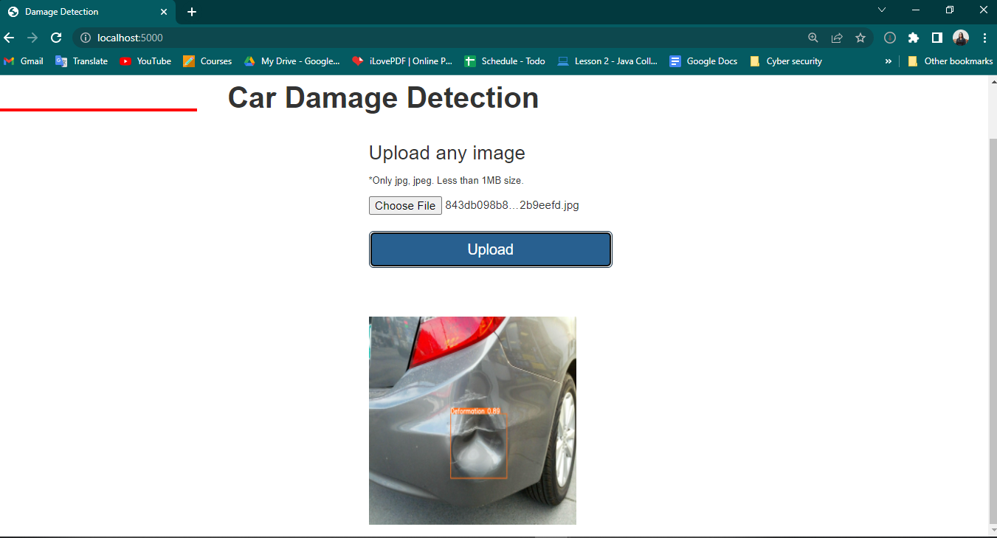

Figure - Prototype web application

## Chapter Summary

This chapter provides an overview of the technology selection process and the technologies chosen for the project. The chapter discusses the algorithmic analysis, data set selection, and development frameworks used in the project, and summarizes the technology stack, programming languages, libraries, and IDEs utilized. It also explains the implementation of the core functionality of the project.

# Chapter 05: CONCLUSION

## Chapter Overview

The conclusion chapter provides a summary of the key findings and outcomes of the project. The chapter highlights the deviations and scope-related issues faced during the project, along with the initial test results and a demo of the prototype. Additionally, the chapter outlines the future work that could be done to improve the system.

## Deviations

### Scope related deviations.

One of the scope-related deviations that were identified in this system is the lack of an image dataset, which makes it impossible to train the model for poor lighting and uncontrolled environments such as rain and snow. Consequently, this issue will not be addressed in this system.

Based on the findings from existing projects, it was realized that the YOLOv5 pre-trained model is more accurate and can be used for damage detection. Therefore, this system will leverage the YOLOv5 pre-trained model for damage detection.

Another aspect that was identified during interviews is that this system will cater to both car owners and insurance companies. It is designed to save their time and resources. By using this system, car owners can quickly assess the damages to their vehicles, and insurance companies can process the claims more efficiently.

However, there is a need to address a critical issue to prevent insurance scams. Currently, an insurance agent needs to be present to assess the previous damages to a vehicle. Without this assessment, individuals could potentially make false claims about damages and commit insurance scams. Hence, this system needs to address this issue to prevent any fraudulent activities.

## Initial Test Results

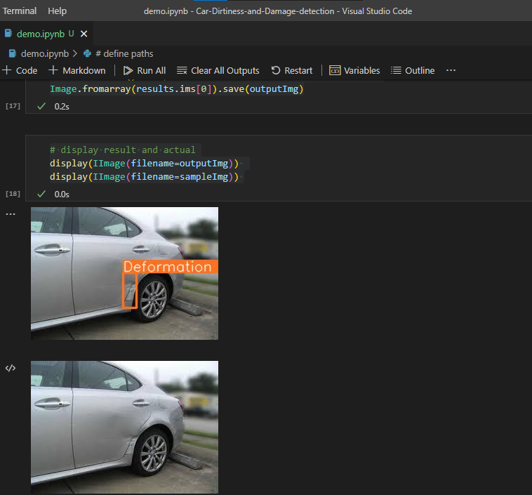

Figure - Initial Test Results

## Demo of the Prototype

**Video** – <https://youtu.be/NIN0d8IM4bo>

**Source code** - <https://github.com/Rasheli-Jayalath/car1.git>

## Chapter Summary

This chapter discusses the deviations and scope-related issues that were encountered during the project, including the lack of an image dataset and the need to address the issue of insurance scams. Secondly, the chapter presents the initial test results that were obtained from the prototype, indicating that the YOLOv5 pre-trained model is accurate and reliable for damage detection. Finally, the chapter provides a demo of the prototype, showcasing the functionalities and features of the system.

# REFERENCES

Adhikari, R.S., Moselhi, O. and Bagchi, A. (no date). Image-based Retrieval of Concrete Crack Properties.

ARAUJO, M. (2022). How to File an Auto Insurance Claim in 5 Easy Steps. [online] Available at: <https://www.thebalance.com/filing-auto-insurance-claim-2645925> [Accessed 06 Feb. 2023].

Dhieb, N., Ghazzai, H., Besbes, H., Massoud, Y., 2019. A Very Deep Transfer Learning Model for Vehicle Damage Detection and Localization, in: 2019 31st International Conference on Microelectronics (ICM). Presented at the 2019 31st International Conference on Microelectronics (ICM), IEEE, Cairo, Egypt, pp. 158–161. <https://doi.org/10.1109/ICM48031.2019.9021687>

Ernst & Young LLP. (2015). Does your firm need a claims leakage study?. [online] Available at: <https://studylib.net/doc/18750398/does-your-firm-need-a-claims-leakage-study%3F>

Gontscharov, S., Baumgärtel, H., Kneifel, A., Krieger, K.-L., 2014. Algorithm Development for Minor Damage Identification in Vehicle Bodies Using Adaptive Sensor Data Processing. Procedia Technol. 15, 586–594. <https://doi.org/10.1016/j.protcy.2014.09.019>

Harshani, W.A.R., Vidanage, K., 2017. Image processing based severity and cost prediction of damages in the vehicle body: A computational intelligence approach, in: 2017 National Information Technology Conference (NITC). Presented at the 2017 National Information Technology Conference (NITC), IEEE, Colombo, pp. 18–21. <https://doi.org/10.1109/NITC.2017.8285649>

Huang, Y., Song, S., Liu, X., Chen, C., Chen, H., & Xie, J. (2020). Research on Automated System for Accident Assessment Based on Multimodal Data. Journal of Advanced Transportation, 2020.

Koch, M., Wang, H., Back, T., 2018. Machine Learning for Predicting the Damaged Parts of a Low Speed Vehicle Crash, in: 2018 Thirteenth International Conference on Digital Information Management (ICDIM). Presented at the 2018 Thirteenth International Conference on Digital Information Management (ICDIM), IEEE, Berlin, Germany, pp. 179–184. <https://doi.org/10.1109/ICDIM.2018.8846974>

Kyu, P.M., Woraratpanya, K., 2020. Car Damage Detection and Classification, in: Proceedings of the 11th International Conference on Advances in Information Technology. Presented at the IAIT2020: The 11th International Conference on Advances in Information Technology, ACM, Bangkok Thailand, pp. 1–6. <https://doi.org/10.1145/3406601.3406651>

Li, L., Yu, Y., Li, X., Chen, Z., & Li, Q. (2020). A Novel Computer Vision Method for Vehicle Damage Detection and Estimation Based on Convolutional Neural Networks. Applied Sciences, 10(7), 2313.

Lin, S.-Y., Tsai, M.-R., 2019. Non-contact Heart Rate Monitoring with Mobile Phone Camera, in: 2019 IEEE International Conference on Consumer Electronics - Taiwan (ICCE-TW). Presented at the 2019 IEEE International Conference on Consumer Electronics - Taiwan (ICCE-TW), IEEE, YILAN, Taiwan, pp. 1–2. https://doi.org/10.1109/ICCE-TW46550.2019.8991766

Liu, Y. et al. (2020). An improved grey wolf optimizer based on differential evolution and OTSU algorithm. Applied Sciences (Switzerland), 10 (18). Available from <https://doi.org/10.3390/APP10186343>

Ministry of transport. (2021). Statistics. [online] Transport.gov.lk. Available at: <http://www.transport.gov.lk/web/index.php/statistics/national-council-for-road-safety.html>.

Nguyen, T.C., 2019. Research to Evaluate the Quality of Passenger Bus Body Frame, Assuring the Passive Safety in the Design Process. Appl. Mech. Mater. 889, 440–447. <https://doi.org/10.4028/www.scientific.net/AMM.889.440>

Parasuraman, S., Sam, A., Yee, S.K., Chuon, B.C., Ren, L., 2017. Smartphone usage and increased risk of mobile phone addiction: A concurrent study. Int. J. Pharm. Investig. 7, 125. <https://doi.org/10.4103/jphi.JPHI_56_17>

Smith, J. (2020). The Future of Vehicle Collision Industry: AI and the Claims Process. Forbes. <https://www.forbes.com/sites/jamessmith/2020/01/31/the-future-of-vehicle-collision-industry-ai-and-the-claims-process/?sh=4ad6930d4232>

Wang, W., Duan, L. and Wang, Y. (2017). Fast Image Segmentation Using Two Dimensional Otsu Based on Estimation of Distribution Algorithm. Journal of Electrical and Computer Engineering, 2017. Available from <https://doi.org/10.1155/2017/1735176>.

Wang, W., Duan, L. and Wang, Y. (2017). Fast Image Segmentation Using Two Dimensional Otsu Based on Estimation of Distribution Algorithm. Journal of Electrical and Computer Engineering, 2017. Available from <https://doi.org/10.1155/2017/1735176>.

Waqas, U., Akram, N., Kim, S., Lee, D., Jeon, J., 2020. Vehicle Damage Classification and Fraudulent Image Detection Including Moiré Effect Using Deep Learning, in: 2020 IEEE Canadian Conference on Electrical and Computer Engineering (CCECE). Presented at the 2020 IEEE Canadian Conference on Electrical and Computer Engineering (CCECE), IEEE, London, ON, Canada, pp. 1–5. <https://doi.org/10.1109/CCECE47787.2020.9255806>

Zhang, Q., Chang, X., Bian, S.B., 2020. Vehicle-Damage-Detection Segmentation Algorithm Based on Improved Mask RCNN. IEEE Access 8, 6997–7004. <https://doi.org/10.1109/ACCESS.2020.2964055>

Zhang, Y. (2014). The design of glass crack detection system based on image preprocessing technology. 2014 IEEE 7th Joint International Information Technology and Artificial Identifying Vehicle Structural Damages using Image Processing.

# APPENDIX

## Appendix A – From Use case Description

|  |  |  |  |
| --- | --- | --- | --- |
| Use case | Detection | Use case ID | 02 |
| Description | Allows the Smart Claim AI system to detect damages in the uploaded vehicle image. | | |
| Primary actor | Smart Claim AI system | Support actor | None |
| Pre-condition | The user has uploaded a valid image of the damaged vehicle. | | |
| Post-condition | The system provides information on the detected damages to the user. | | |
| Initial step | The system receives the uploaded image for analysis. | | |
| Main Success  scenario | The system analyzes the uploaded image to identify any damages present in the vehicle.  The system identifies and detects the location of the damages.  The system provides information on the detected damages to the user.  Variations -  If the system fails to detect any damages, it prompts the user to upload another image or provides an error message.  If the uploaded image is of poor quality, the system prompts the user to upload a higher quality image or provides an error message. | | |

|  |  |  |  |
| --- | --- | --- | --- |
| Use case | View History | Use case ID | 03 |
| Description | Allows the user to view previous reports of their damaged vehicles. | | |
| Primary actor | User (vehicle owner) or Insurance agent | Support actor | Smart Claim AI system |
| Pre-condition | User has access to the Smart Claim AI system and has previously reported a damaged vehicle. | | |
| Post-condition | The user can view the history of their previous reports. | | |
| Initial step | User requests to view the history of their previous reports. | | |
| Main Success  scenario | The user navigates to the history section of the system.  The user selects the damaged vehicle report they wish to view.  The system retrieves and displays the selected report to the user.  Variations -  If the user has not reported any damaged vehicles previously, the system displays an appropriate message. | | |

|  |  |  |  |
| --- | --- | --- | --- |
| Use case | User Login | Use case ID | 04 |
| Description | Allows the user to log in to the Smart Claim AI system. | | |
| Primary actor | User | Support actor | Smart Claim AI system |
| Pre-condition | User has access to the Smart Claim AI system and a valid account. | | |
| Post-condition | The user is logged in to the system and can access the system features. | | |
| Initial step | User requests to log in to the system. | | |
| Main Success  scenario | The user navigates to the login section of the system.  The user enters their login credentials.  The system validates the credentials and logs the user in.  Variations -  If the user enters invalid login credentials, the system prompts them to enter valid credentials or provides an error message.  If the user does not have a valid account, the system prompts them to create an account or provides an error message. | | |

|  |  |  |  |
| --- | --- | --- | --- |
| Use case | Classifying Damage | Use case ID | 05 |
| Description | Allows Smart Claim AI system to classify the type of damage present in the vehicle body. | | |
| Primary actor | Smart Claim AI system | Support actor | None |
| Pre-condition | Image need to be uploaded and processed by the system. | | |
| Post-condition | Damage type is classified and the system proceeds to classify the damage severity. | | |
| Initial step | User selects the option to classify the damage type. | | |
| Main Success  scenario | User selects the option to classify the damage type  System processes the uploaded image and classifies the damage type  System proceeds to classify the damage severity  Variations –  If the system is unable to classify the damage type accurately, it prompts the user to upload a clearer image or seek assistance from a professional. | | |

|  |  |  |  |
| --- | --- | --- | --- |
| Use case | Detecting Damage | Use case ID | 06 |
| Description | Allows Smart Claim AI system to detect the presence of damage in the vehicle body. | | |
| Primary actor | Smart Claim AI system | Support actor | None |
| Pre-condition | Image need to be uploaded and processed by the system. | | |
| Post-condition | System confirms the presence of damage in the vehicle body. | | |
| Initial step | User selects the option to detect damage in the vehicle body . | | |
| Main Success  scenario | User selects the option to detect damage in the vehicle body  System processes the uploaded image and confirms the presence of damage  Variations –  If the system is unable to detect any damage, it prompts the user to upload a clearer image or seek assistance from a professional. | | |

|  |  |  |  |
| --- | --- | --- | --- |
| Use case | Calculate Damage | Use case ID | 07 |
| Description | Allows Smart Claim AI system to calculate the extent of damage present in the vehicle body. | | |
| Primary actor | Smart Claim AI system | Support actor | None |
| Pre-condition | Image need to be uploaded and processed by the system. | | |
| Post-condition | Extent of damage is calculated and the system proceeds to estimate the cost of repair. | | |
| Initial step | User selects the option to calculate the extent of damage. | | |
| Main Success  scenario | User selects the option to calculate the extent of damage  System processes the uploaded image and calculates the extent of damage  System proceeds to estimate the cost of repair  Variations –  If the system is unable to accurately calculate the extent of damage, it prompts the user to upload a clearer image or seek assistance from a professional. | | |

|  |  |  |  |
| --- | --- | --- | --- |
| Use case | Estimate Cost | Use case ID | 08 |
| Description | Allows Smart Claim AI system to estimate the cost of repairing the damage present in the vehicle body. | | |
| Primary actor | Smart Claim AI system | Support actor | None |
| Pre-condition | Extent of damage needs to be calculated and processed by the system. | | |
| Post-condition | Estimated cost of repair is displayed to the user. | | |
| Initial step | User selects the option to estimate the cost of repair. | | |
| Main Success  scenario | User selects the option to estimate the cost of repair  System processes the extent of damage and estimates the cost of repair  Estimated cost of repair is displayed to the user  Variations –  If the system is unable to accurately estimate the cost of repair, it prompts the user to upload a clearer image or seek assistance from a professional. | | |

## Appendix B – From Implementation

### Flask application Implementation source code

## Appendix C – From survey

### Survey question 4 - Chart of responses

### Survey question 5 - Chart of responses

### Survey question 6 - Chart of responses

### Survey question 7 - Chart of responses

### Survey question 8 - Chart of responses

### Survey question 9 - Responses

|  |
| --- |
| no  No  nope  Automated system should able to identity above mention damage as well as to state them correctly  Cost to replace air bags and seat belts  N/A  No  Easy to use Interface (Look up Geico in the USA)  Able to very the estimation from another person so the results will be more accurate  Good interface  Detect of inner damages that cannot be observed through automated system  Estimate bill  No  According to the principles of insurance, Indemnity is significant. If a loss occurs to an insured property, the compensation should be sufficient to reinstate the damage to the previous state. But, the damage is not reinstated when they haven't quality products. Example: If damage occurred to the windscreen, the insurance company provides compensation to purchase poor parts which are not able to reinstate the vehicle to the previous situation. Thus, it is noteworthy to reinstate the vehicle by using quality parts. It is suggested to use an automated system to estimate the value of the damage.  np  not so far  should have a good user interface.  NG  If you have an insurance. Why bothering how much money would be cost. That will be covered by the insurance company. And after a accident insurance agent coming only for check the damage. Not giving the estimate. I had 2 accidents but the insurance guy came on other day. Sometimes they s yo whatsapp. And we can call. Immediately when a accident happens. |

### Survey question 10 - Chart of responses

### Survey question 11 - Chart of responses

## Appendix D – Diagrams

### Sequence Diagram

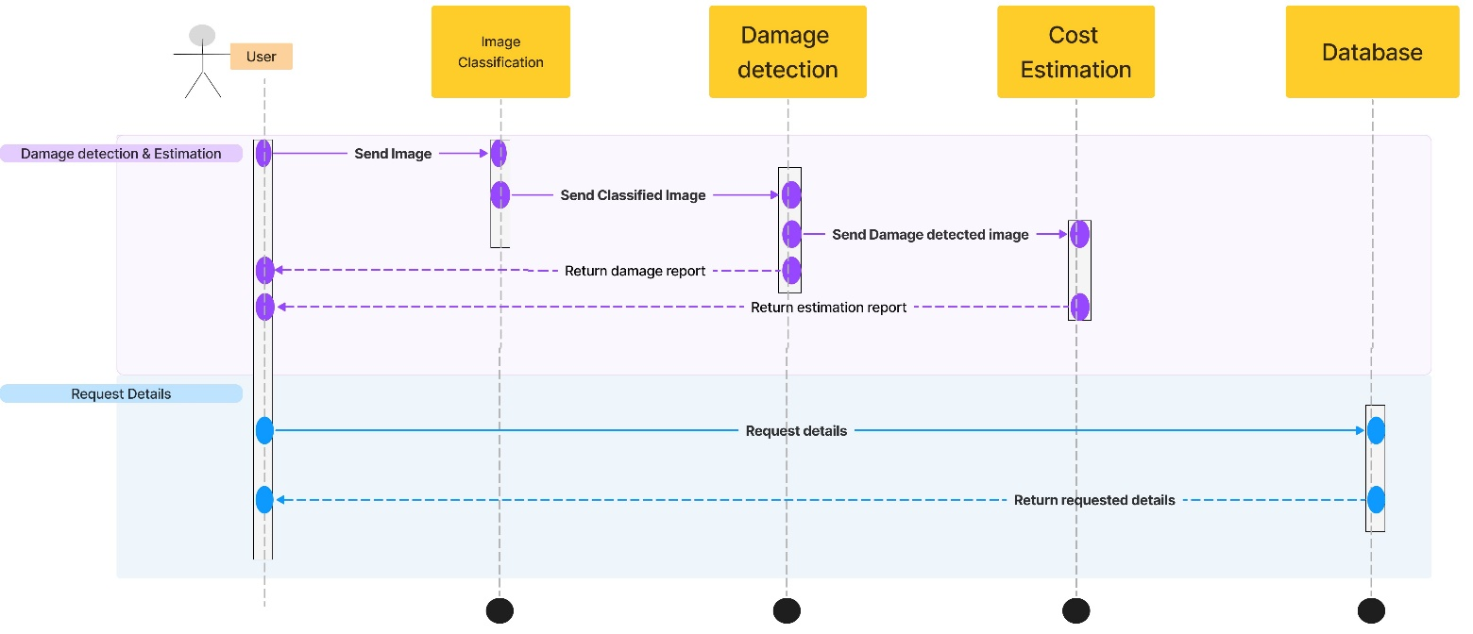

Back to the 1st Chapter

Back to the table of content